Persian Rug: Enduring Appeal & Longevity Explained
today as they were when they were first woven. But what makes Persian rugs so special? Why do they last for generations while other rugs deteriorate and fade over time? In this blog post, we'll explore the unique qualities that give Persian rugs their timeless appeal.
The Art of Persian Rug Making
Persian rugs are more than just functional floor coverings; they are works of art. Each rug is crafted by hand using traditional techniques that have been passed down through generations of skilled artisans. Persian rug makers use natural fibers such as wool, silk, and cotton, which are hand-dyed using natural dyes. The fibers are then painstakingly woven into intricate patterns and designs, with each knot being tied by hand. The result is a rug that is not only beautiful but also durable and long-lasting.
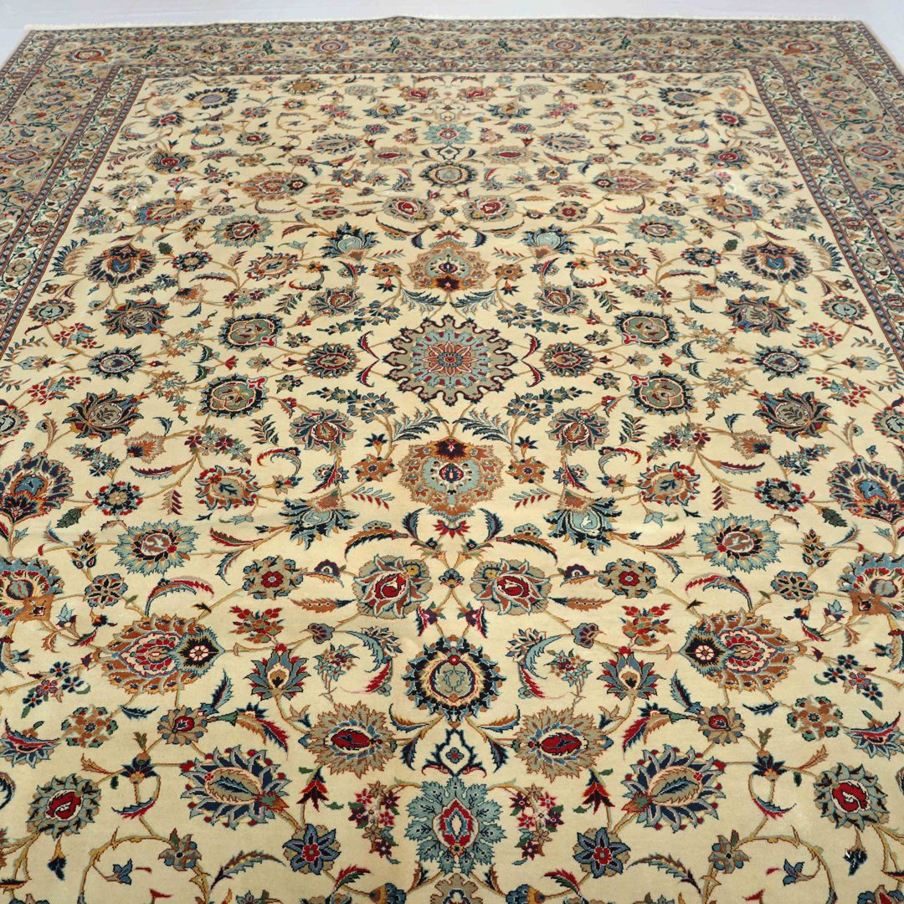
Quality of Materials
One of the key factors that contribute to the longevity of Persian rugs is the quality of the materials used. The wool that is used to create these rugs is of the highest quality, sourced from sheep that graze in the mountains of Iran. This wool is known for its durability and resilience, which allows the rug to withstand heavy foot traffic and retain its shape over time. In addition, the natural dyes used to color the fibers are also of the highest quality, which means that the colors will not fade or bleed over time.
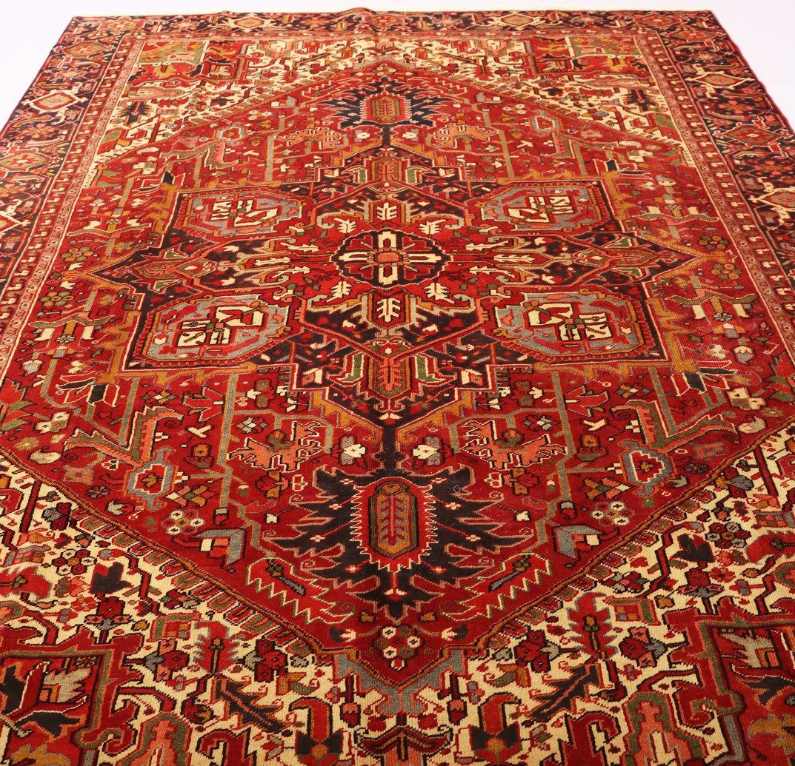
Design and Pattern
The designs and patterns found on Persian rugs are another factor that contributes to their longevity. These rugs are not just decorative; they are also functional, providing insulation and warmth in cold climates. The intricate patterns and designs found on Persian rugs have been perfected over centuries and are designed to be both aesthetically pleasing and functional. These designs also help to conceal wear and tear, allowing the rug to remain beautiful even after years of use.
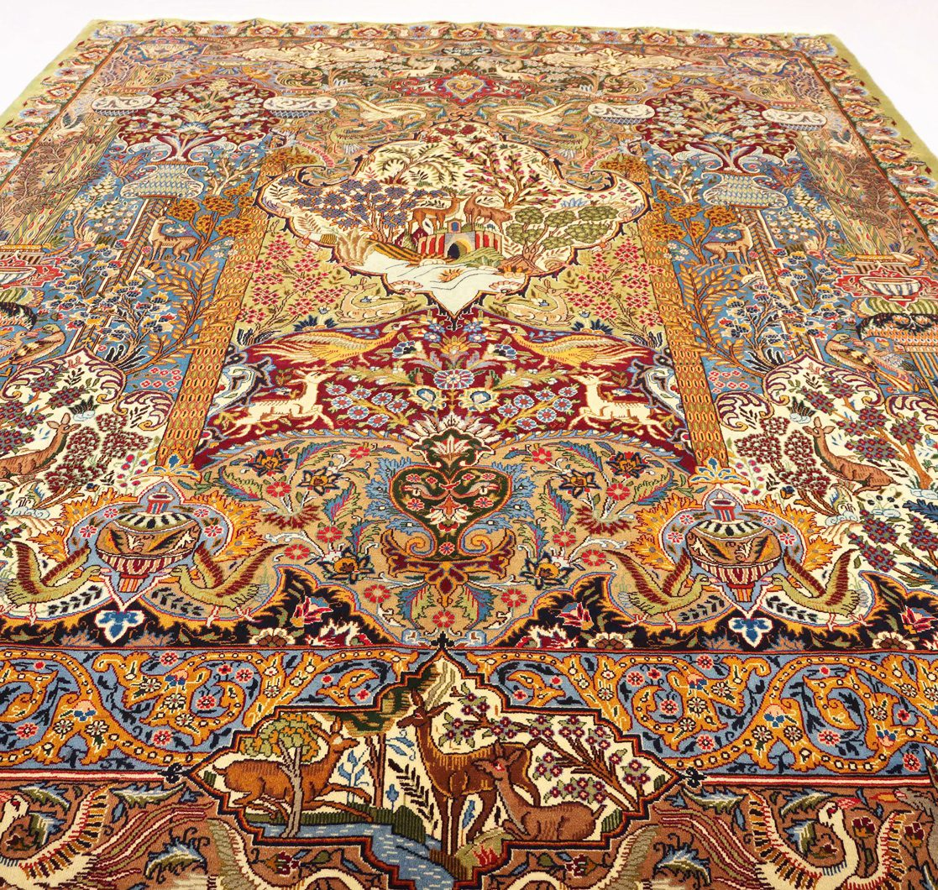
Cleaning and Maintenance
Proper cleaning and maintenance are essential for keeping Persian rugs looking their best. These rugs should be vacuumed regularly to remove dirt and debris that can become embedded in the fibers. Spills should be blotted immediately to prevent staining, and professional cleaning should be done every few years to remove deep-seated dirt and stains. By taking care of your Persian rug, you can ensure that it remains in excellent condition for generations to come.
Investment Value
Another reason why Persian rugs last for generations is their investment value. These rugs are not just beautiful works of art; they are also valuable assets that can appreciate in value over time. Because Persian rugs are crafted using traditional techniques and high-quality materials, they are often considered to be a sound investment. As a result, many families pass down their Persian rugs from generation to generation, treating them as treasured family heirlooms.
In conclusion, Persian rugs have a timeless appeal that has made them a favorite among collectors and interior designers for centuries. With their exquisite beauty, intricate designs, and impressive durability, these rugs have become cherished family heirlooms that are passed down from generation to generation. By understanding the unique qualities that give Persian rugs their longevity, you can appreciate the beauty and value of these works of art for years to come.
buy a rug
At our website, we offer a vast selection of authentic Persian rugs that are hand-woven by skilled artisans. Our rugs are made of high-quality materials and feature exquisite designs that are both timeless and unique. We take pride in offering the best customer service, ensuring that your shopping experience is seamless and enjoyable. Plus, we offer competitive pricing and fast, reliable shipping. By purchasing from us, you can trust that you are getting a genuine, one-of-a-kind Persian rug that will last for generations. Don't settle for less - shop with us today and experience the beauty and elegance of Persian rugs for yourself!

