Match Persian rug with your decoration: a complete guide
Persian rugs are one of the most beautiful and luxurious pieces of home decor, and they can add a touch of elegance and sophistication to any space. However, choosing the right Persian rug to match your home decor can be daunting, especially if you're unfamiliar with the different styles, patterns, and colors available. In this comprehensive guide, we'll provide tips and ideas for selecting the perfect Persian rug that complements your home decor and adds warmth and personality to your living space.
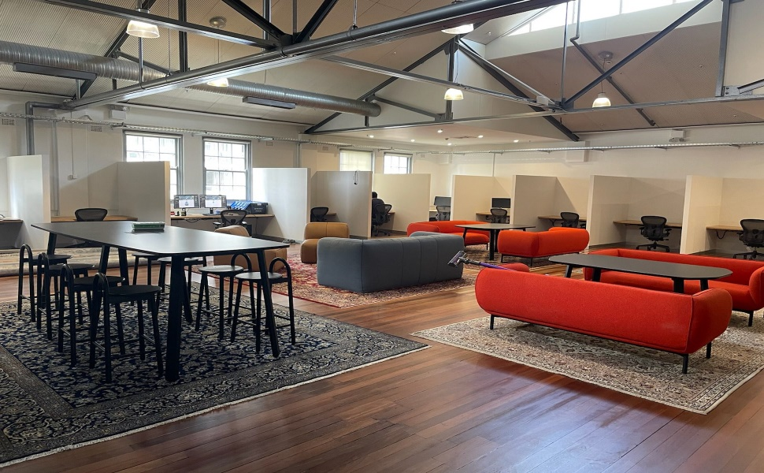
Consider the size of the rug:
The first thing you must consider when choosing a Persian rug is its size. The rug should be proportional to the size of your room and its furniture. A small rug can get lost in a large room, while a large rug can overwhelm a small space. Measure the size of your room and furniture and choose a rug that fits comfortably and leaves enough space around the edges.
Choose the right style:
Persian rugs come in various styles, each with its unique pattern, color, and texture. Some popular styles include Tabriz, Kashan, and Nain. Each style has unique features and characteristics, so it's important to choose one that complements your home decor and personal style.
For example, if you have contemporary or minimalist home decor, you might choose a Persian rug with a simple geometric pattern and a neutral color palette. If you have a more traditional or ornate decor, you might prefer a rug with a more intricate floral pattern and rich, bold colors.
Pay attention to the color:
The rug's color is another important factor to consider when choosing a Persian rug for your home. The rug should complement the colors of your walls, furniture, and accessories rather than clash with them. If you have neutral-colored walls and furniture,
If you have neutral-colored walls and furniture, a Persian rug with a bold, vibrant pattern and rich colors can add a pop of color and interest to the space. On the other hand, if you have colorful walls and furniture, a rug with a more subtle, neutral color palette can help balance out the space and prevent it from looking too busy or overwhelming.
When choosing the color of your Persian rug, consider the overall color scheme of your home decor. If your walls and furniture are mostly warm colors like reds, oranges, and yellows, a rug with cool colors like blues and greens can create a nice contrast and balance. If your walls and furniture are mostly cool colors, a rug with warm colors like reds and oranges can add warmth and coziness to the space.
Mix and match patterns:
Mixing patterns can be tricky, but when done right, it can add interest and depth to your home decor. If you have patterned furniture or accessories in your home, consider choosing a Persian rug with a complementary pattern. For example, if you have a floral-patterned couch, a rug with a smaller floral pattern can add depth and interest to the space without overwhelming it.
Alternatively, you can mix patterns by choosing a rug with a bold, graphic pattern that contrasts with the patterns in your furniture and accessories. This can create a fun and eclectic look that adds personality and character to your home decor.
Layer rugs:
Layering rugs is another way to add interest and texture to your home decor. A Persian rug can add warmth and softness to the space if you have hardwood or tile floors. However, if you want to add more texture and dimension to the space, consider layering a smaller rug on top of the Persian rug.
For example, you can layer a small sheepskin or cowhide rug over a larger Persian rug to create a cozy and inviting space. Alternatively, you can layer a flat-weave rug over a Persian rug to create a subtle pattern and add depth to the space.
Buy a Rug
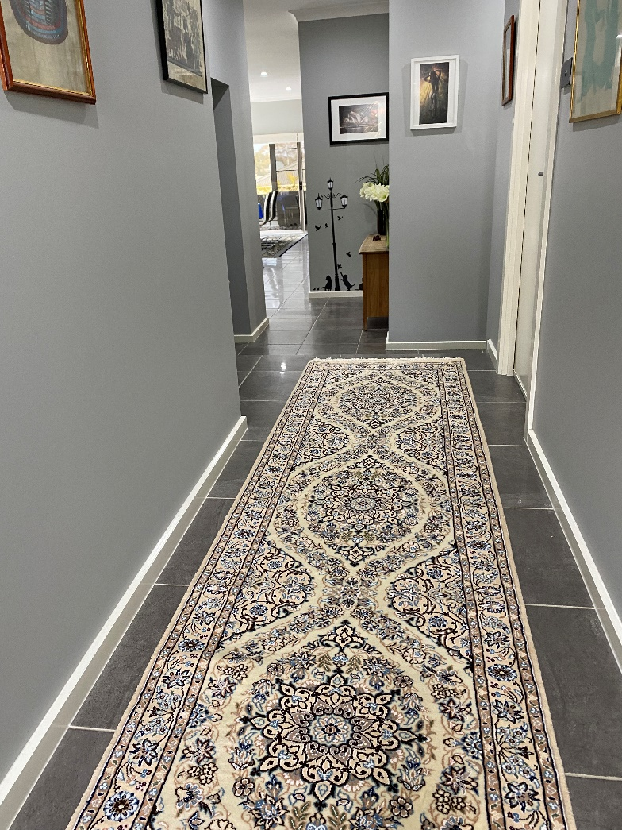
In conclusion, choosing the right Persian rug for your home decor can be a fun and rewarding experience. By considering the size, style, color, and pattern of the rug, you can create a space that is warm, inviting, and full of personality. Don't be afraid to mix and match patterns or layer rugs to create a unique and eclectic look that reflects your personal style and taste.
If you want to buy a Persian Rug, visit our website store. Our collection of Persian rugs includes various styles, colors, and patterns to choose from, ensuring that you can find the perfect rug to complement your home decor. Our rugs are made from high-quality materials and are crafted by skilled artisans, so you can rest assured that you're getting a product that is not only beautiful but also durable and long-lasting. We offer competitive pricing and excellent customer service, making us the go-to destination for all your Persian rug needs. Shop our collection today and add a touch of elegance and luxury to your home.

