7 Reasons to Choose a Persian Rug for Your Home Decor
ersian rug offer durability, intricate designs, and a rich history, making them a top choice for home decor. However, it's important to use active voice rather than passive voice. In this article, we'll explore ten reasons why a Persian rug should be your next home decor purchase.
Let's dive into the different types of Persian rugs:
Tribal Rugs: Persian rugs are unique works of art, reflecting the history and culture of the weaver. Often hand-woven by tribal communities, these rugs use traditional techniques passed down through generations.
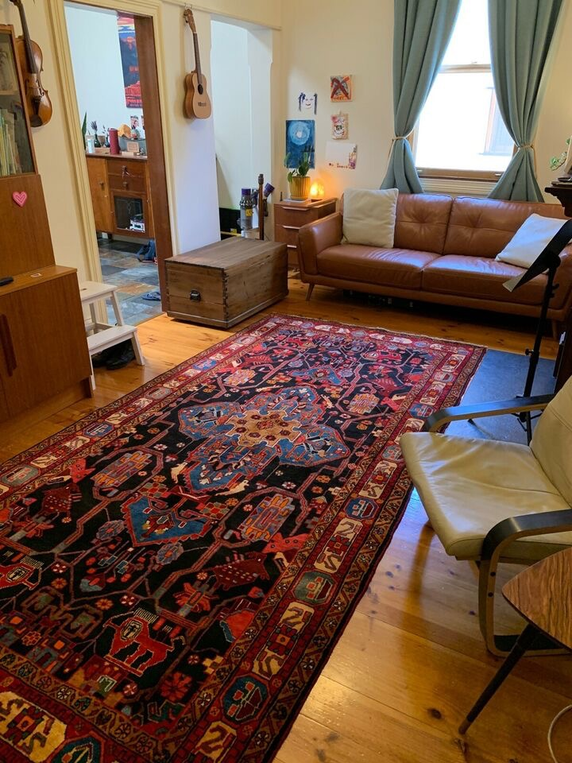
Hallway Runners: If you're looking for a way to add style and elegance to your hallway, Persian runners are the perfect choice. These narrow rugs are designed to fit perfectly in a hallway, adding a touch of luxury to your space.
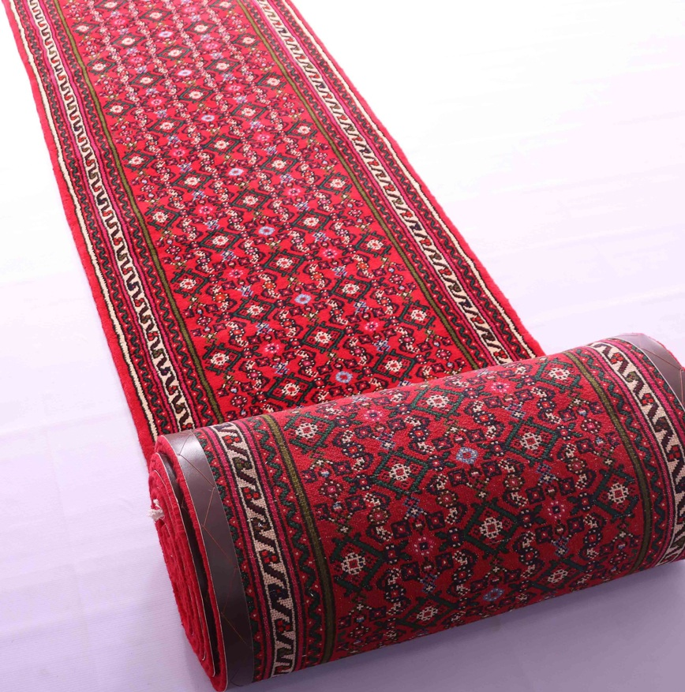
Traditional Rugs: With intricate designs and beautiful colors, traditional Persian rugs are a timeless addition to any home decor. They can be used in any room of the house, from the living room to the bedroom.
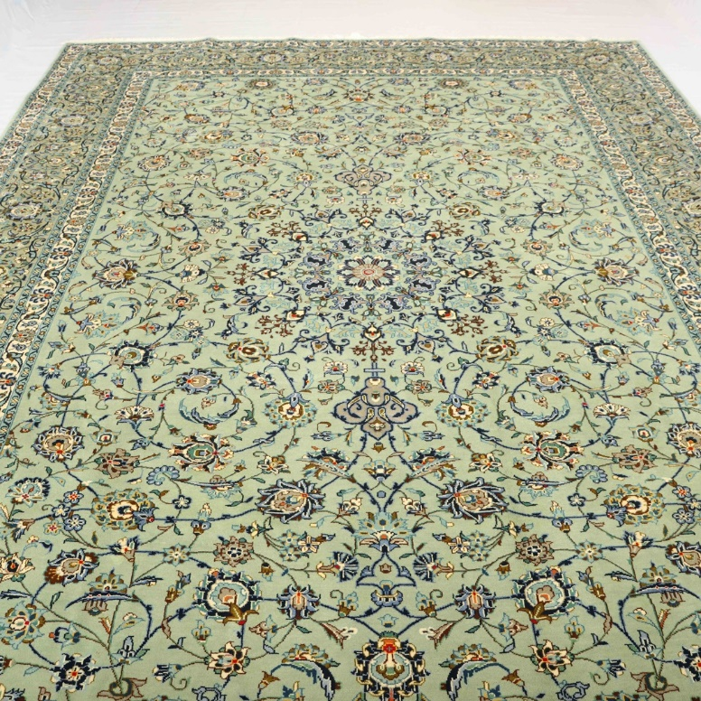
Nomadic Rugs: Nomadic rugs are some of the most sought-after Persian rugs, woven by nomadic tribes who travel throughout Iran. Each rug tells a story of the weaver's travels.
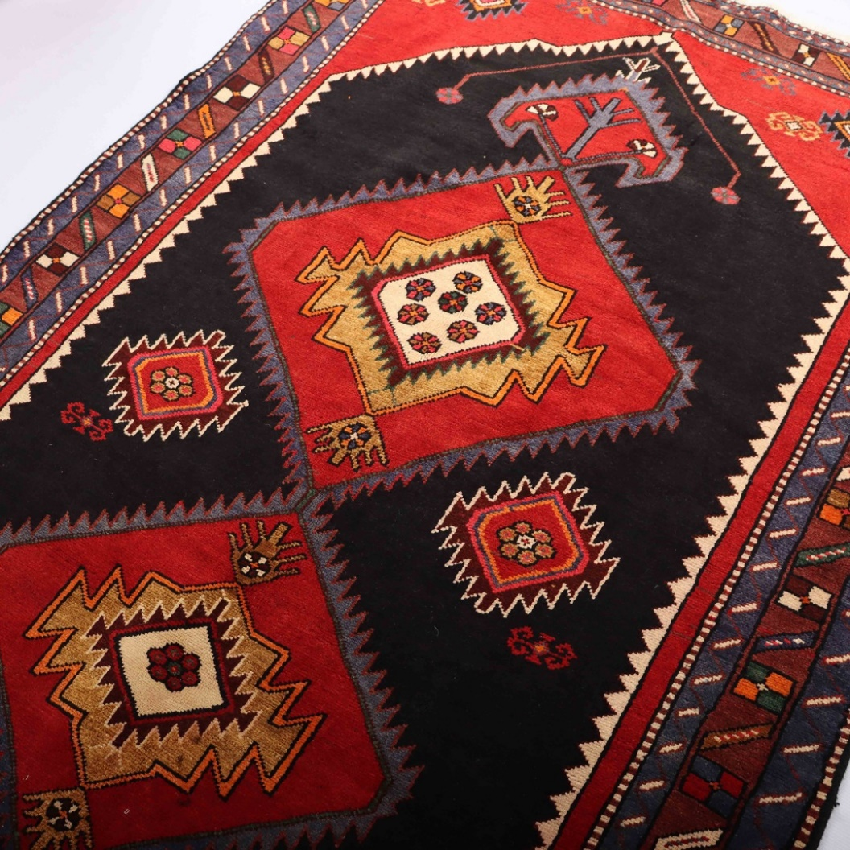
Shiraz Rugs: Bold designs and vibrant colors are the hallmark of Shiraz rugs, named after the city of Shiraz, which is known for its rich history and culture.
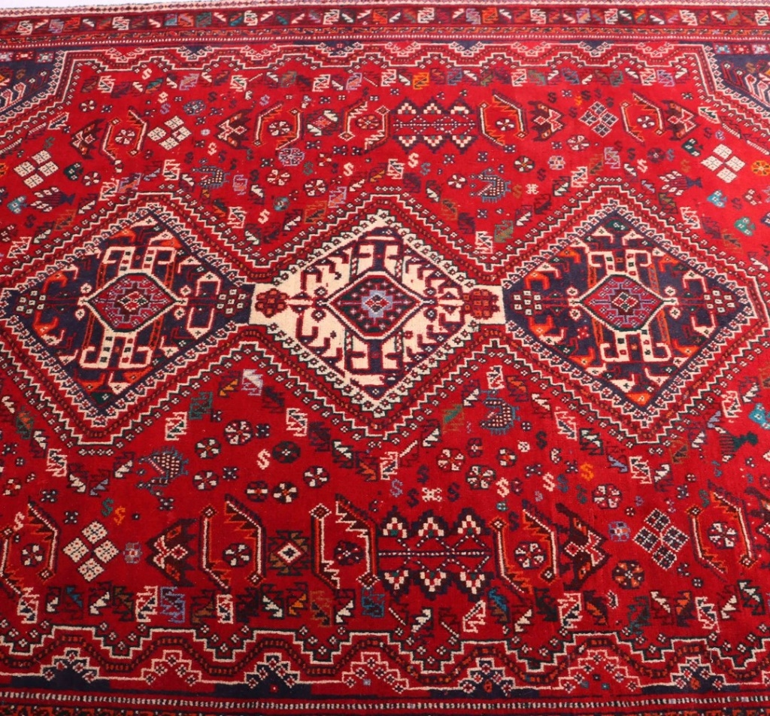
Balouchi Rugs: Smaller than other Persian rugs, Balouchi rugs are the perfect choice for smaller rooms. These rugs are known for their intricate designs and beautiful colors.
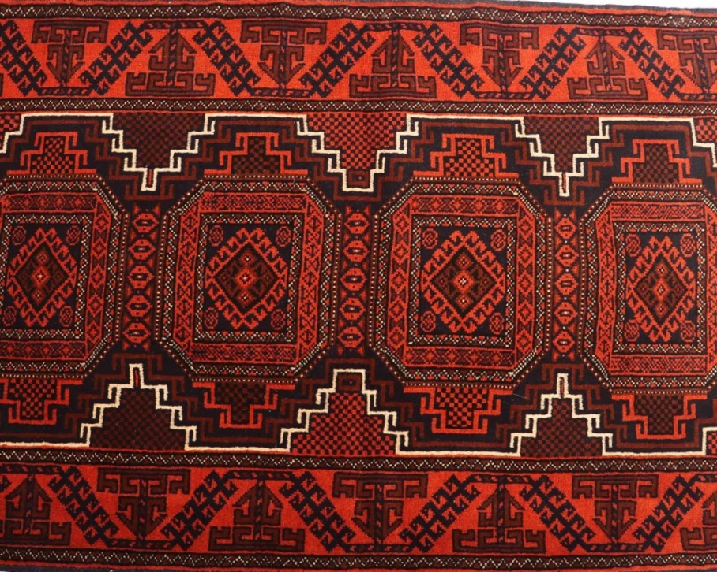
Fish Design Rugs: Persian rug collectors often choose fish design rugs, which symbolize prosperity and abundance with their fish motifs.
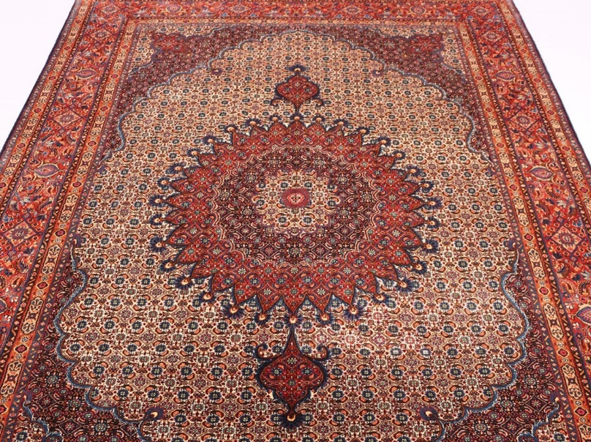
In summary, Persian rugs are a beautiful and timeless addition to any home decor. They offer durability, rich history, and intricate designs, making them a treasured family heirloom for generations to come. So why not make a Persian rug your next home decor purchase?
Buy a rug
If you're interested in buying a Persian rug, visit our website. We offer an extensive collection of authentic handmade Persian rugs from various regions of Iran, ensuring exceptional quality and stunning designs. Our commitment to excellent customer service ensures a great shopping experience for our customers. Browse our collection today and add a timeless touch to your home decor with one of our beautiful Persian rugs.

