Why are Persian rugs so expensive?
Persian rugs are renowned for their intricate designs, rich colors, and exceptional quality. These handwoven carpets have been prized possessions for centuries, gracing the floors of palaces, homes, and museums worldwide. While their beauty is undeniable, the cost of Persian rugs can be daunting for some buyers. So, what makes Persian rugs so expensive? Let's dive into the art and craftsmanship behind these exquisite carpets.
High-Quality Materials
One of the main reasons for the high cost of Persian rugs is the use of premium materials. The finest Persian rugs are made from natural materials such as wool, silk, and cotton. The wool is sourced from the best breeds of sheep and goats, carefully selected for their softness, strength, and sheen. The silk used in Persian rugs is often derived from the cocoons of the mulberry silkworm, known for its fine and lustrous fibers. The cotton used in the foundation of Persian rugs is also of the highest quality, providing a strong and durable base for intricate designs.
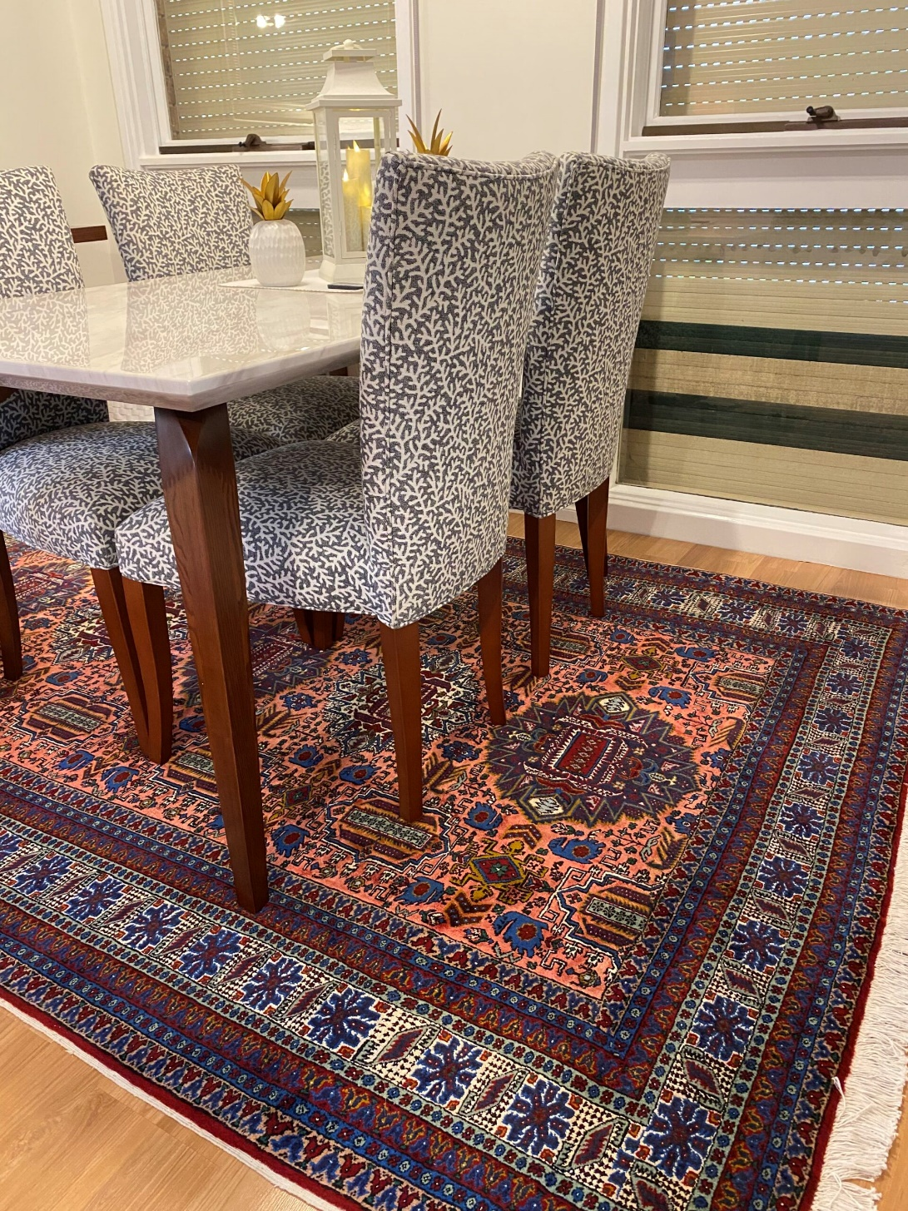
Time-Intensive Process
Another factor contributing to the high cost of Persian rugs is the time-intensive process of making them. Each Persian rug is hand-knotted by skilled weavers who use traditional techniques that have been passed down through generations. The process of weaving a Persian rug can take anywhere from several months to several years, depending on the size and complexity of the design. The weavers must work diligently and precisely to ensure every knot is tied with care, resulting in a flawless final product.
Unique Designs
Persian rugs are known for their unique designs, inspired by Iran's culture and history. Each Persian rug tells a story, often featuring motifs and symbols that have been used for centuries. These designs are beautiful and meaningful, reflecting the values and beliefs of the people who created them. The intricate patterns and colors of Persian rugs require a great deal of skill and artistry to produce, making each rug an actual work of art.
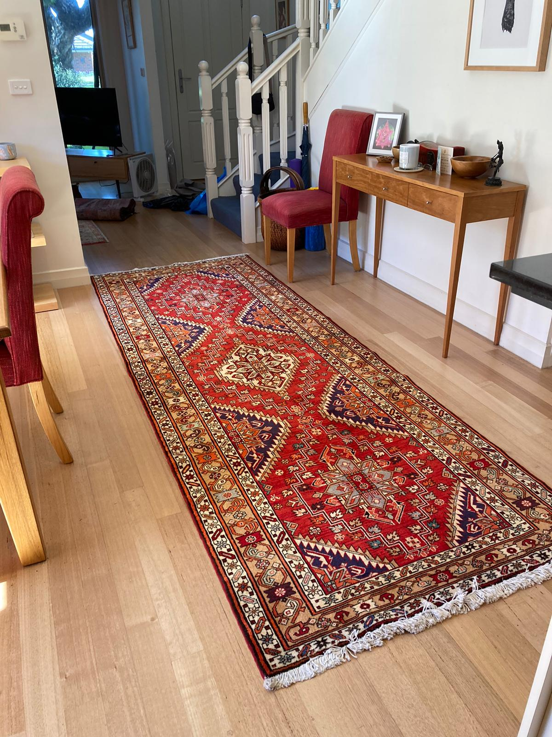
Rarity and Collectability
Finally, the high cost of Persian rugs can also be attributed to their rarity and collectability. Many Persian rugs are one-of-a-kind, making them highly sought-after by collectors and connoisseurs. Some Persian rugs are considered museum-quality pieces due to their historical and cultural significance. As such, the value of Persian rugs can be appreciated over time, making them a wise investment for those who appreciate their beauty and craftsmanship.
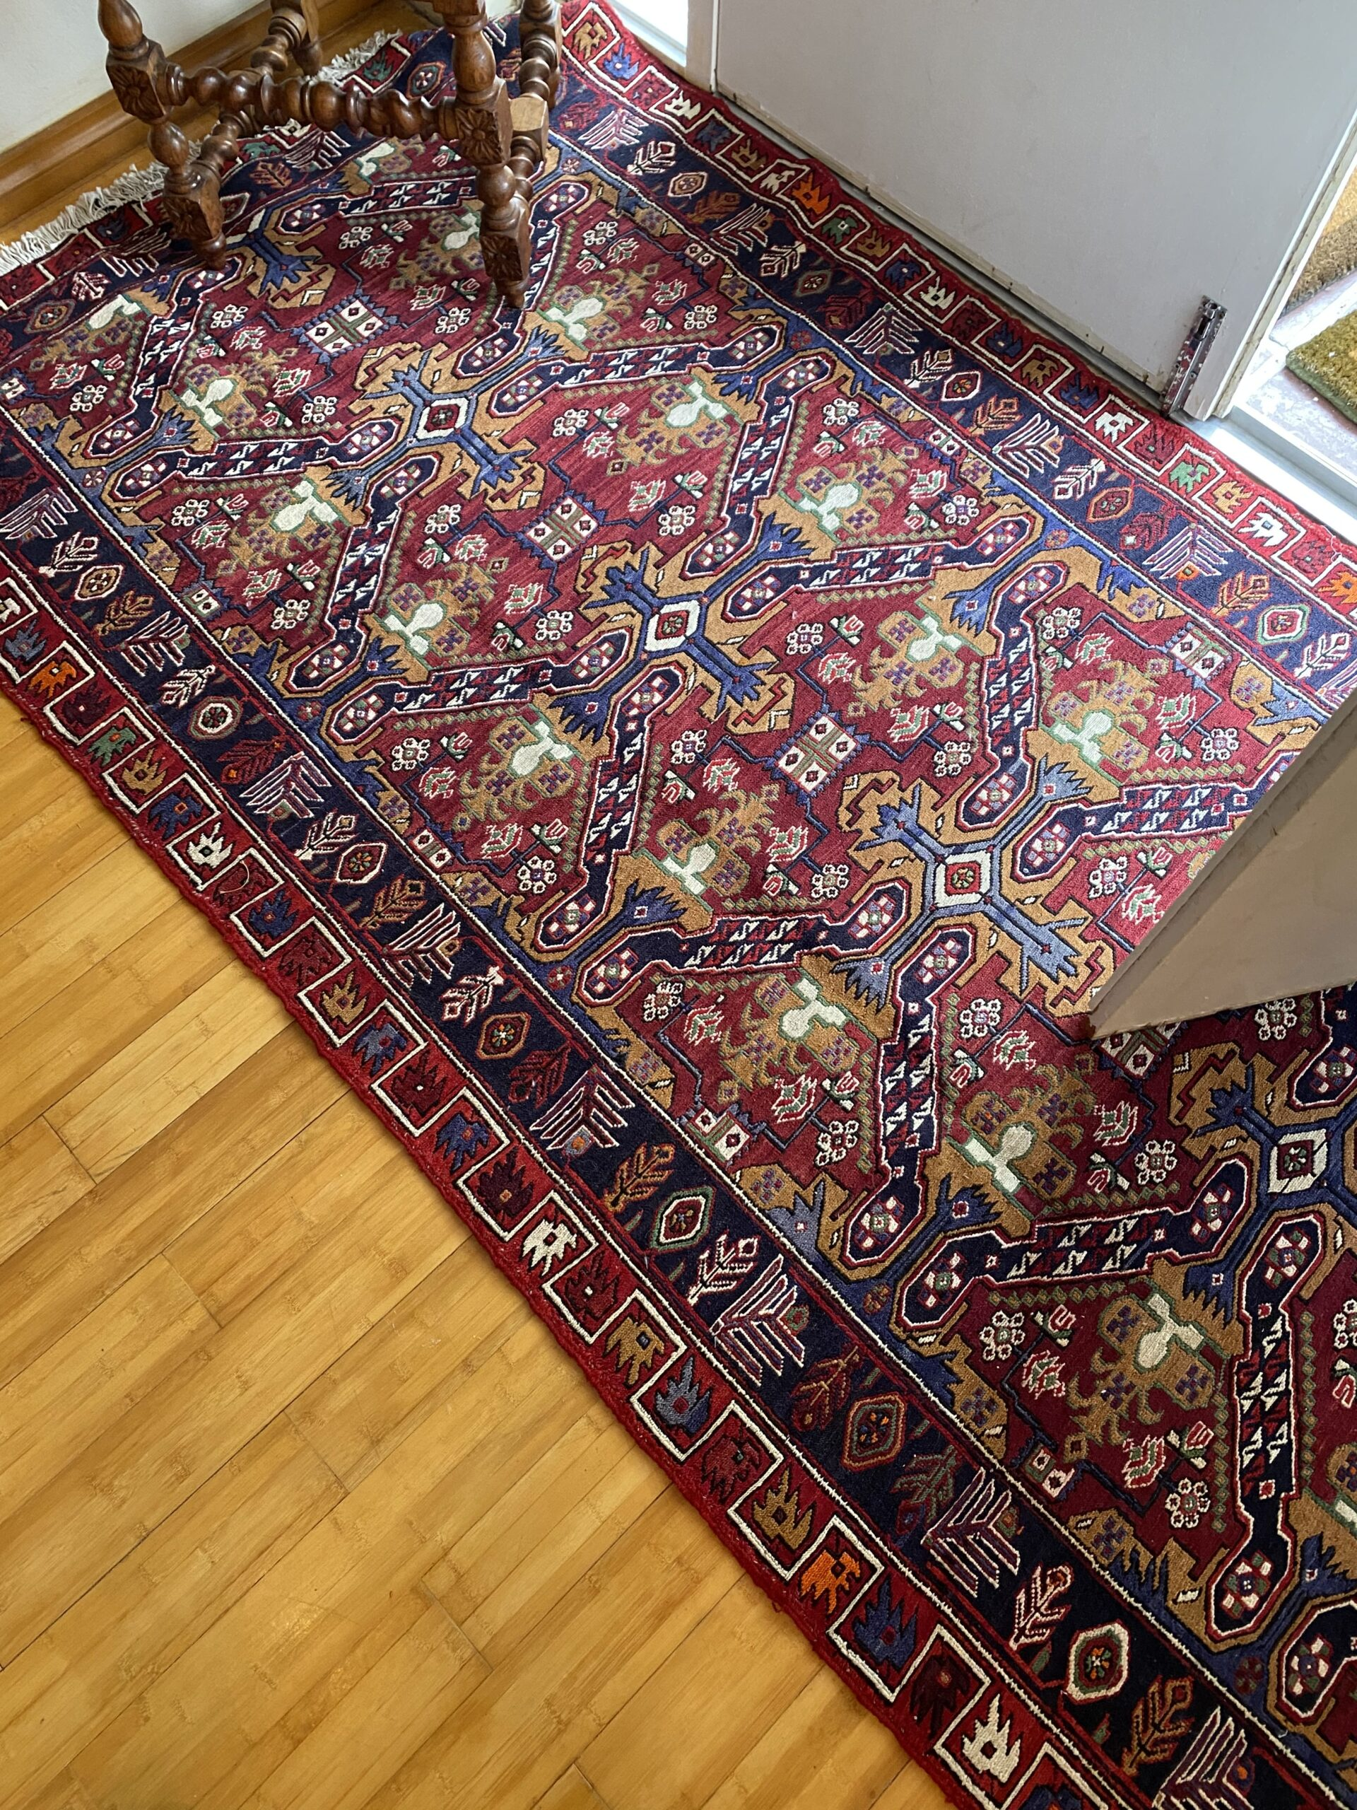
At RugMaster, we take pride in our selection of high-quality Persian rugs sourced directly from Iran. Our rugs are made from premium materials, hand-woven by skilled artisans, and feature unique designs that add warmth and elegance to any room. While our prices are competitive, we believe our Persian rugs' cost reflects their exceptional quality and artistry.
In conclusion, the cost of Persian rugs can be attributed to the use of high-quality materials, the time-intensive process of making them, their unique designs, and their rarity and collectability. At RugMaster, we offer a wide variety of Persian rugs that are sure to suit any taste and budget. Shop our selection today to find the perfect rug for your home or office.

