Unraveling the Artistry of Persian Rugs: A Journey Through Time
If you are looking for a high-quality and unique addition to your home decor, you might want to consider a Persian rug. Handwoven with wool or silk, these carpets are known for their intricate patterns and vibrant colors, making them a stunning centerpiece in any room.
RugMaster offers a vast selection of Persian rugs for sale, directly imported from Iran to Australia. As a rug shop with over a decade of experience in Iran, we guarantee the quality of our products and offer competitive prices for all budgets. In this blog post, we will take you on a journey through the artistry and history of Persian rugs, exploring their characteristics, styles, and cultural significance.
What Makes Persian Rugs So Special?
Persian rugs are handmade carpets that originate from Iran, formerly known as Persia. They have a long history, dating back to ancient times, and are considered one of the world's most valuable and prestigious forms of art. Persian rugs are special because of their intricate design, superior craftsmanship, and the use of high-quality materials such as wool or silk.
Making a Persian rug is a labor-intensive and time-consuming art form. It involves several steps: shearing, washing, carding, dyeing, spinning, and weaving. Each step requires skill and precision, and the weaver must pay close attention to detail to create a flawless final product.
The Designs and Styles of Persian Rugs
Persian rugs come in various designs and styles, each representing a unique cultural and artistic heritage. The most common types of Persian rugs include traditional rugs, vintage rugs, tribal rugs, and modern Persian rugs.
Traditional rugs are known for their intricate floral and geometric patterns, usually featuring a central medallion surrounded by smaller motifs. These rugs often have a formal and sophisticated look, making them ideal for formal settings such as living rooms and dining rooms.
Vintage Persian rugs are at least 50 years old and have a distinct and charming aged appearance. They often feature muted colors and soft patterns, giving them a timeless and nostalgic feel.
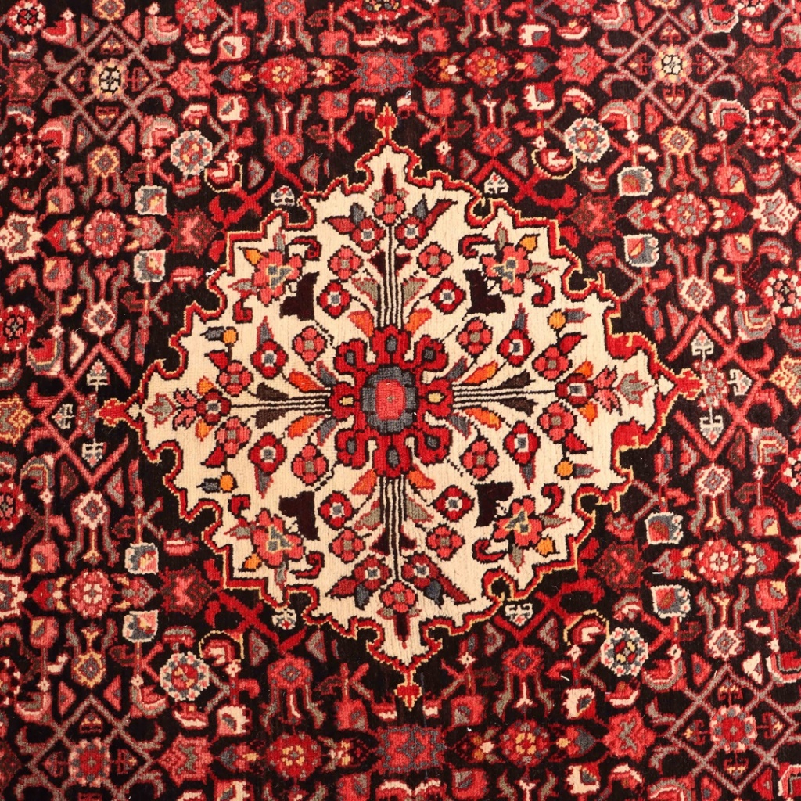
Tribal rugs, conversely, are made by nomadic tribes and feature bold and vibrant designs. They are usually made with wool and are highly durable, making them perfect for high-traffic areas such as hallways and entryways.
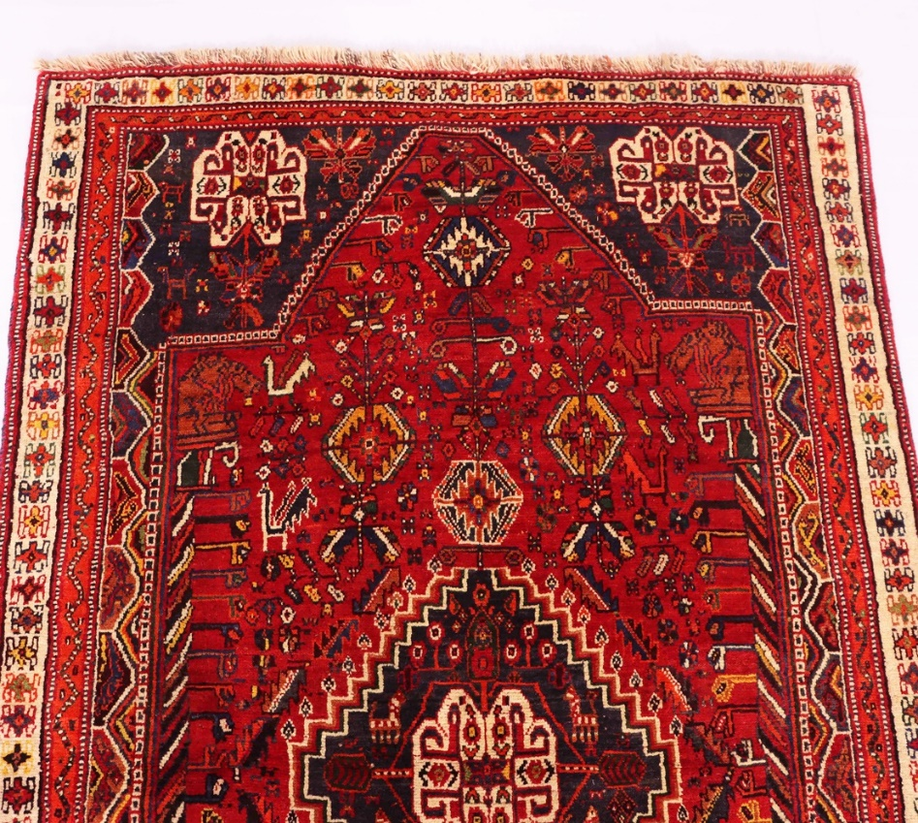
Modern Persian rugs are a contemporary take on traditional designs, often featuring bold and abstract patterns in bright colors. They are perfect for adding a pop of color and style to any room and are suitable for traditional and modern decor.
The Colors of Persian Rugs
Persian rugs are famous for their vibrant colors, which are achieved through the use of natural dyes made from plants and insects. The most common colors used in Persian rugs include red, blue, green, and black.
Red Persian rugs are the most popular and highly prized among collectors, as they are believed to represent luck and prosperity. Blue Persian rugs, however, are associated with tranquility and serenity, making them perfect for bedrooms and meditation rooms. Green Persian rugs represent nature and growth, while black Persian rugs symbolize elegance and sophistication.
Where to Find Persian Rugs in Australia
If you want to buy a Persian rug in Australia, RugMaster is your go-to destination. Our rug warehouse features a vast selection of handmade rugs in various sizes, styles, and colors, including vintage Persian rugs, tribal rugs, modern Persian rugs, and more. We also offer hallway runners for sale in various lengths, including 4m hallway runners and 6m hall runners, making it easy to find the perfect fit for your space.
Whether you are in Sydney, Melbourne, Perth, Brisbane, Hobart, Or anywhere in Australia, we can ship for you For FREE
Small Persian Rug
For those looking for a rug to add a touch of luxury to a smaller space, a small Persian rug can be an excellent choice. These rugs come in various patterns and colors and are perfect for adding color and style to any room. They also work well in entryways or foyers, adding a touch of elegance to the space.
Vintage Rugs
Vintage Persian rugs are a great way to add character and charm to any space. These rugs have been around for decades, each telling a unique story. They come in various styles and designs, from traditional to modern, and can add a touch of elegance and history to any room. They also work well in various spaces, from living rooms and bedrooms to home offices and libraries.
Tribal Rugs
Tribal Persian rugs are known for their bold, geometric designs and bright colors. They are often handwoven by nomadic tribes and reflect their culture and traditions. These rugs can add a touch of exoticism to any room and work well in eclectic or bohemian-style spaces.
Oriental Rugs
Oriental rugs are similar to Persian rugs but are typically made in countries such as China, Turkey, and India. These rugs feature intricate designs and patterns, often with a floral or geometric theme. They come in various colors and sizes, making them a versatile option for any room.
Hallway Runners
Hallway runners are a great way to add warmth and color to your hallways. They come in various styles and lengths, from short accent runners to long, statement pieces. If you are looking for hallway runners for sale, RugMaster has a wide selection to choose from. With various colors, patterns, and sizes available, you are sure to find the perfect hallway runner to fit your style and budget.
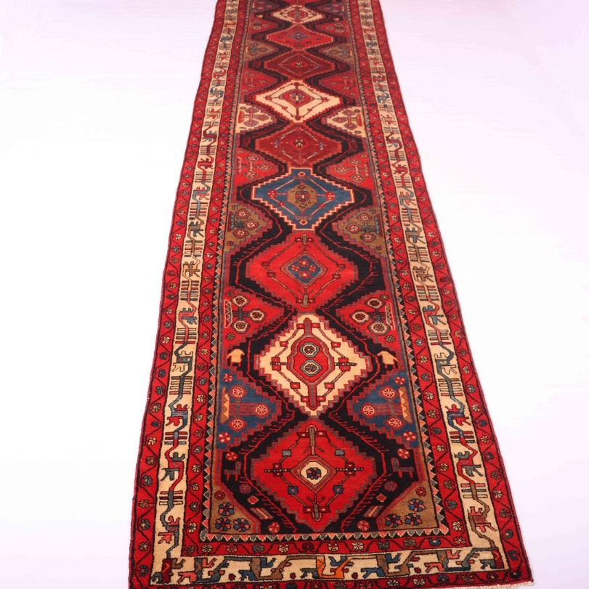
Large Persian Rug
A large Persian rug can be a statement piece in any room. These rugs come in various sizes, making them a versatile option for larger rooms. They feature intricate designs and patterns and can add depth and character to any space.
Silk Persian Rug
Silk Persian rugs are known for their softness, sheen, and intricate designs. These rugs are often considered to be some of the most luxurious and expensive rugs available. They work well in formal living rooms, bedrooms, or any space where you want to add a touch of luxury and elegance.
Tabriz Rug
Tabriz rugs are known for their intricate designs and high quality. They are handwoven in the city of Tabriz in Iran and feature a variety of colors and patterns. These rugs can add a touch of sophistication to any space and work well in traditional or modern settings.
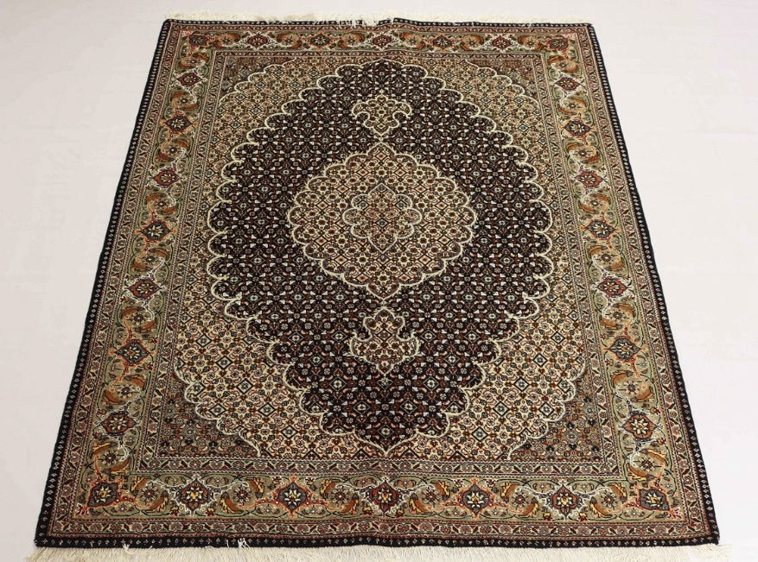
Round Persian Rug
Round Persian rugs are a great way to add a unique touch to any room. These rugs come in various sizes and colors and can be used as a statement piece or as a complementary piece to another decor. They work well in living rooms, dining rooms, or bedrooms.
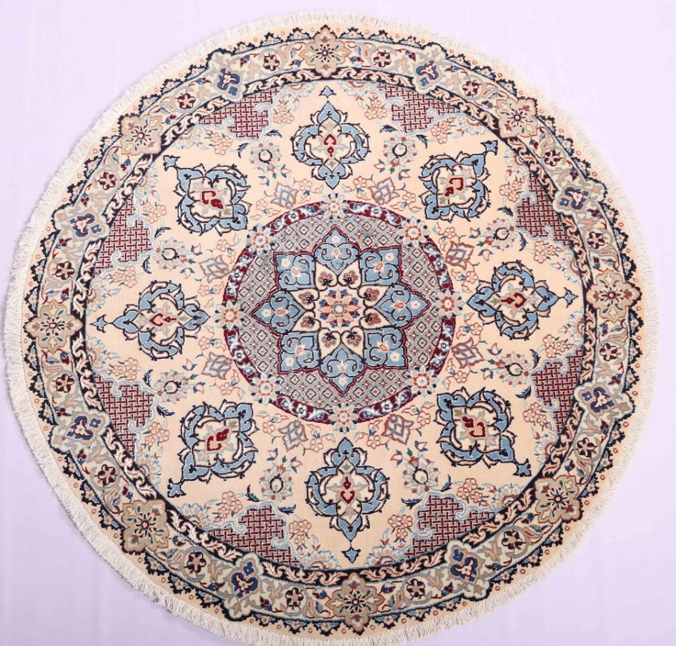
Nomadic Rugs
Nomadic Persian rugs are often handwoven by nomadic tribes in Iran. They feature bold, geometric designs and bright colors and are a reflection of the tribe's culture and traditions
