The Top Persian Rug Styles to Complement Your Home Decor 💯
A Persian rug is more than just a floor covering - it is a work of art that can elevate the look and feel of any room. With their intricate designs, rich history, and durability, Persian rugs have been a popular choice for homeowners for centuries. If you want to add a touch of elegance and sophistication to your home decor, here are the top Persian rug styles to consider.
- Traditional Persian Rugs Traditional Persian rugs are known for their intricate designs and beautiful colors, making them a timeless addition to any home. These rugs are typically made of wool, silk, or a combination of the two and are hand-woven using traditional techniques passed down through generations. With their classic designs and durability, traditional Persian rugs are a great investment for any homeowner.
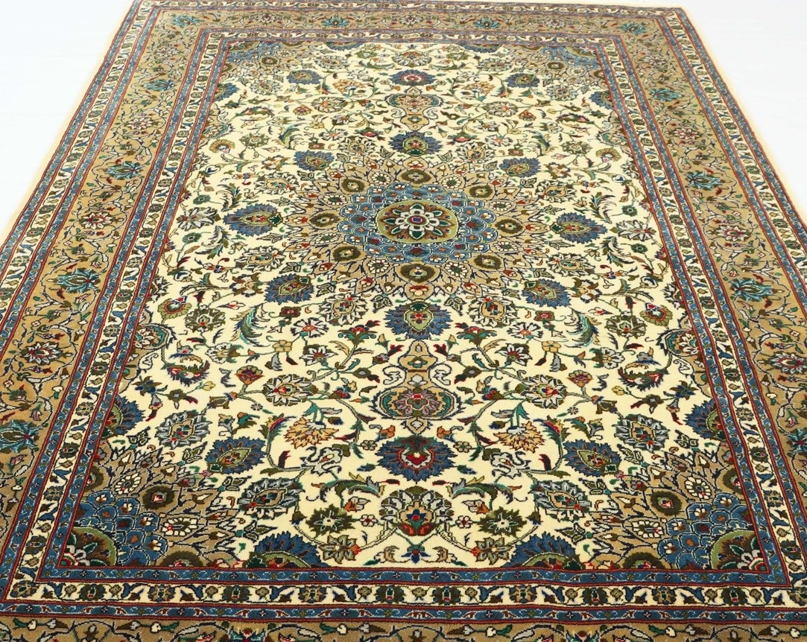
- Tribal Persian Rugs Tribal Persian rugs are another popular style and are often hand-woven by tribal communities using traditional techniques. Each rug is unique and reflects the history and culture of the weaver, making them a great conversation piece in any room. Tribal rugs often feature geometric patterns and bold colors and can add a touch of bohemian or rustic charm to your home decor.
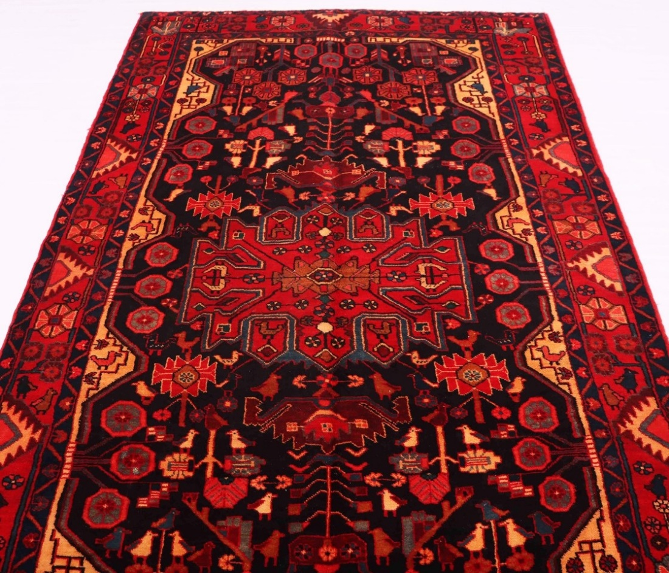
- Vintage Persian Rugs Vintage Persian rugs are a great way to add a touch of history and character to your home decor. These rugs are typically over 50 years old and have a unique patina and character that can't be replicated. Vintage Persian rugs are often more affordable than new rugs, making them a great option for homeowners on a budget who still want to add a touch of elegance to their homes.
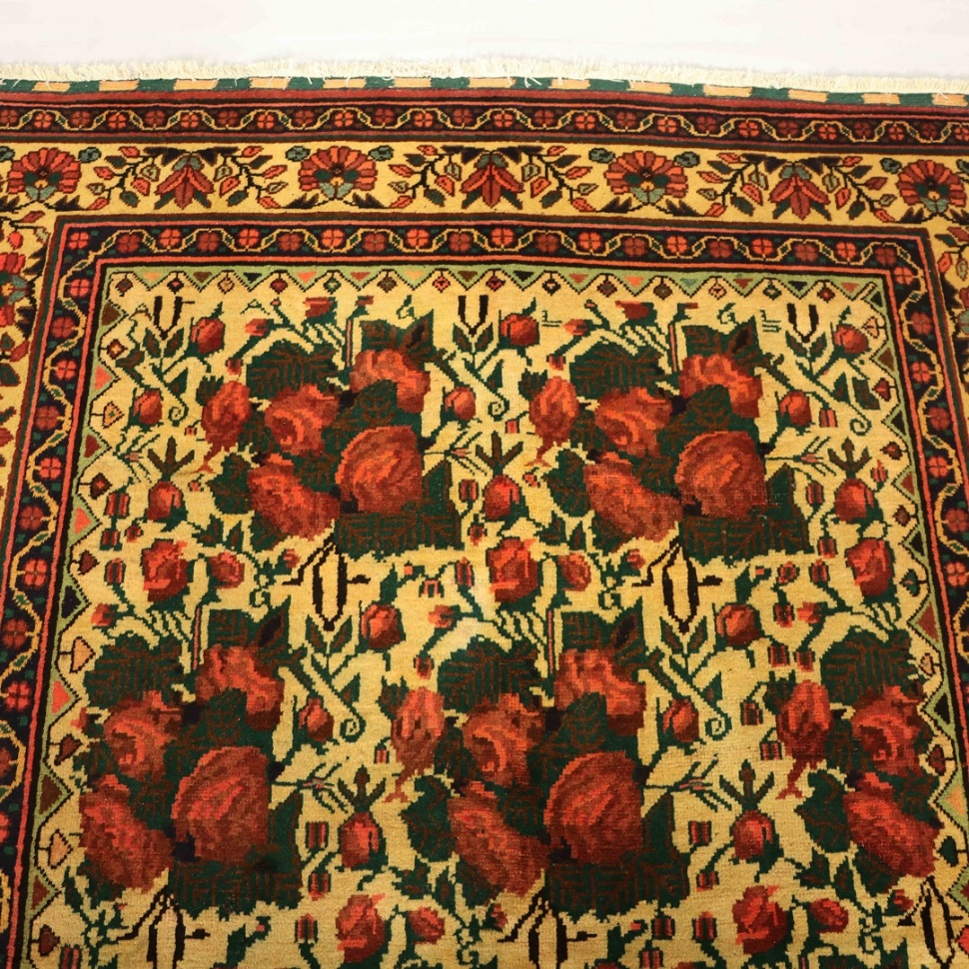
- Oriental Persian Rugs Oriental Persian rugs are known for their intricate patterns and rich colors and are often made of silk or a silk and wool blend. These rugs are typically more expensive than other styles, but their luxurious look and feel make them worth the investment. Oriental Persian rugs can add a touch of luxury to any room and are often found in formal living rooms and dining rooms.
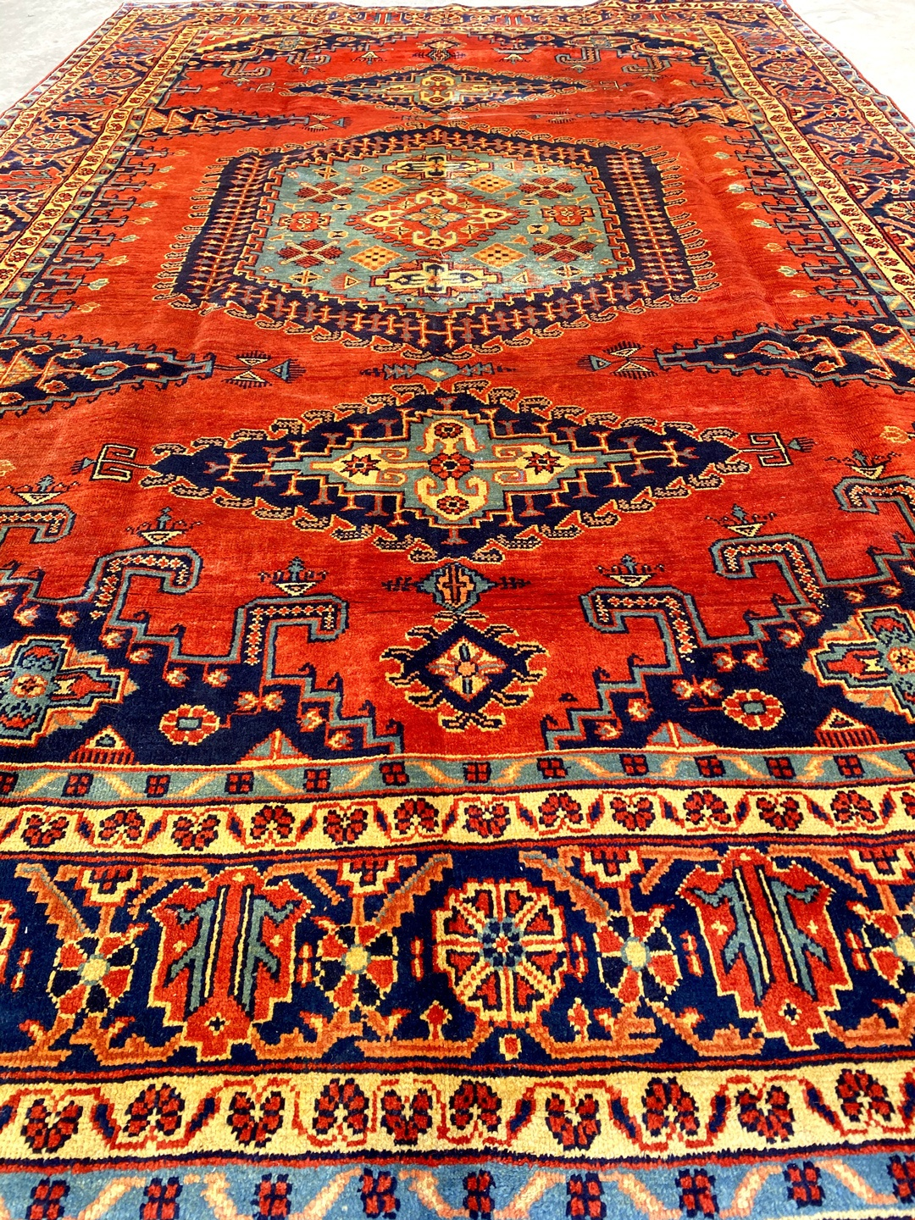
- Balouchi Rugs Balouchi rugs are often smaller than other Persian rugs, making them an excellent choice for smaller rooms or areas. These rugs are known for their intricate designs and beautiful colors and are often made by the Balouchi tribes in eastern Iran. Balouchi rugs are a great way to add a touch of bohemian or rustic charm to your home decor.
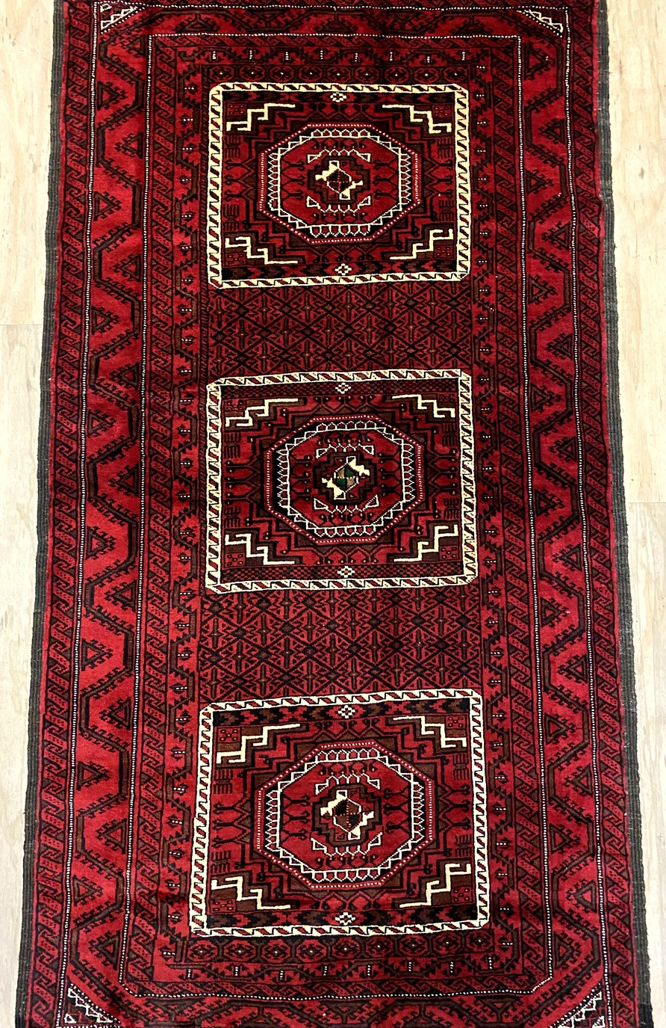
- Shiraz Rugs Shiraz rugs are named after the city of Shiraz in Iran, known for its rich history and culture. These rugs are often bold and vibrant, with intricate designs and bright colors. Shiraz rugs are a great way to add a touch of color and energy to any room and can be a great focal point in your home decor.
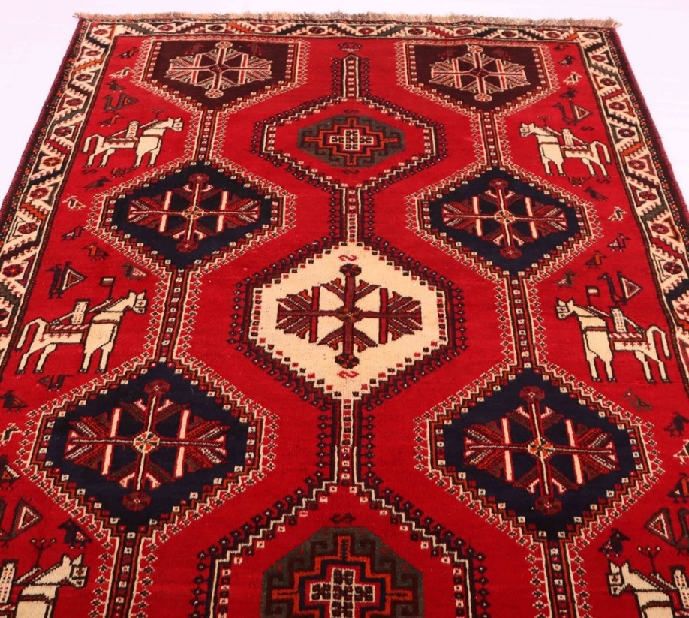
- Hallway Runners Hallway runners are a great way to add style and elegance to your home decor while protecting your floors. Persian hallway runners come in various styles and colors and can be custom-sized to fit your hallway perfectly. Whether you're looking for a bold, vibrant design or a more subtle and traditional look, a Persian hallway runner will fit your style.
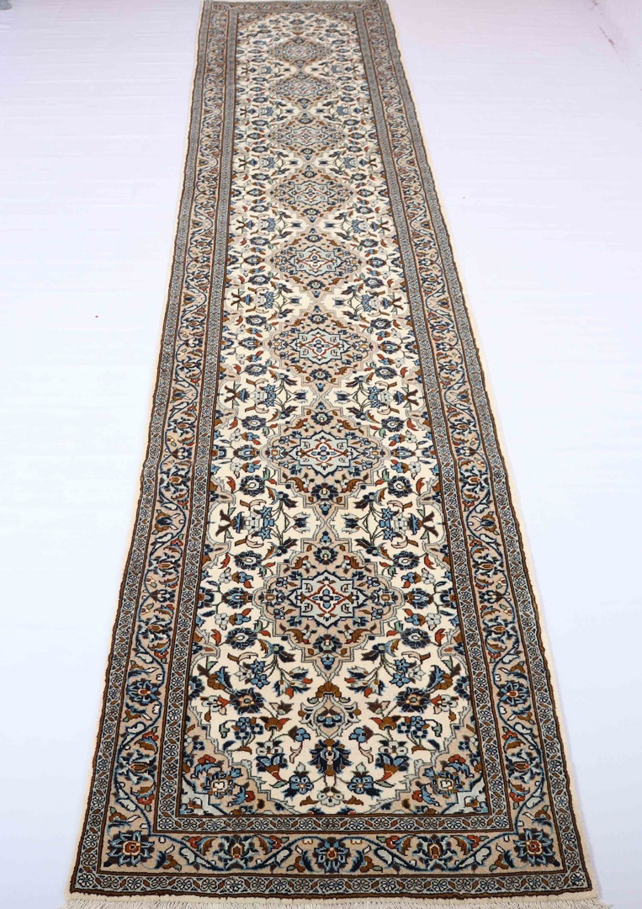
- Red Persian Rugs Red Persian rugs are a classic choice that can add warmth and vibrancy to any room. These rugs often feature intricate patterns in shades of red, orange, and gold and can be a great focal point in your home decor. Red Persian rugs are often found in living rooms and bedrooms and can add a touch of luxury to your space.
- Blue Persian Rugs Blue Persian rugs are a great way to add a touch of tranquility and calm to your home decor. These rugs often feature intricate patterns and designs in various shades of blue, ranging from soft pastels to rich jewel tones. The color blue has a calming effect on the mind and can create a sense of serenity and peace in any room. A blue Persian rug can complement various furniture styles, from modern to traditional, and can be used in any house. A blue Persian rug can be the perfect choice for a bedroom, providing a calming and soothing atmosphere for a good night's sleep. In a living room or den, a blue Persian rug can create a cozy and inviting space for relaxing and entertaining. Whether you choose a classic or modern design, a blue Persian rug will be a timeless addition to your home decor.
Persian rugs are more than just functional floor coverings - they are works of art that have stood the test of time. With their intricate designs, rich history, and durability, Persian rugs have been a popular choice for homeowners for centuries. This article highlights the top Persian rug styles to consider, from traditional and tribal designs to vintage and Oriental rugs. Each type has its own unique characteristics and can add a touch of elegance and sophistication to any home decor. The article also discusses the benefits of hallway runners and the classic choices of red and blue Persian rugs, which can add warmth and tranquility to any room.
If you're looking to add a touch of elegance and sophistication to your home decor, then look further than our website for Persian rugs. Our vast collection of Persian rugs features a wide range of styles and designs, from traditional to vintage and everything in between. Each rug is hand-woven using traditional techniques and high-quality materials, ensuring that they are not only beautiful but also durable and long-lasting. Our easy-to-use website allows you to browse and shop our collection from the comfort of your own home, with detailed descriptions and images of each rug to help you make an informed decision. Plus, we offer competitive pricing and fast and reliable shipping, so you can get the perfect Persian rug delivered right to your doorstep. Don't settle for a mass-produced rug when you can have a beautiful and unique work of art that will elevate your home decor to the next level. Shop with us today and experience the beauty and quality of Persian rugs firsthand.

