Latest Posts: change block type or style
Block Latest Posts is the only block, and cannot be moved
Block Latest Posts is the only block, and cannot be moved

The Best Australian Rugs for Your Home Decor
Looking to add a touch of elegance to your home decor? Look no further than Australian rugs. With a wide range of stylish and high-quality options available, you can elevate the look of any room in your home. Discover the finest Australian rugs and transform your space into a cozy and sophisticated haven.
﻿

Choose the Right Size and Shape for Your Space.
When selecting an Australian rug for your home decor, it's important to consider the size and shape that will best suit your space. A rug that is too small can make a room feel disjointed, while a rug that is too large can overwhelm the space. Measure the area where you plan to place the rug and choose a size that allows for a border of flooring to show around the edges. Additionally, consider the shape of the room and the furniture placement. Rectangular rugs are versatile and work well in most spaces, while round rugs can add a unique touch to a room with curved furniture or a circular layout. By choosing the right size and shape for your space, you can ensure that your Australian rug enhances the overall aesthetic of your home decor.
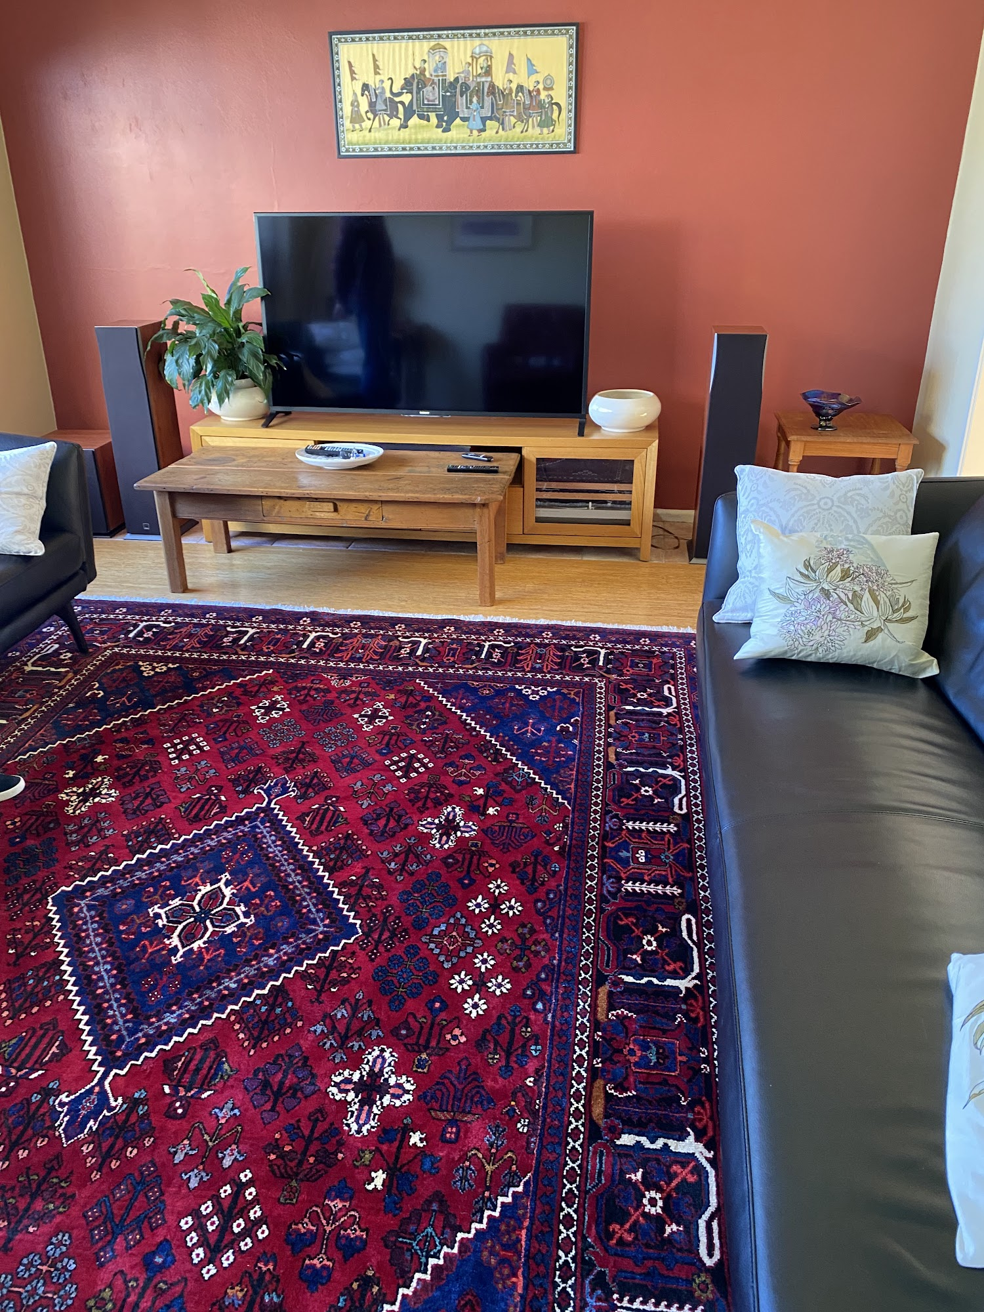

Consider the Material and Texture.
When choosing an Australian rug for your home decor, it's important to consider the material and texture of the rug. Different materials and textures can create different looks and feel in a room. For example, a wool rug can add warmth and coziness to a space, while a silk rug can add a touch of luxury and elegance. Additionally, consider the durability and maintenance requirements of the rug. Some materials may be more prone to staining or wear and tear, so it's important to choose a rug that fits your lifestyle and needs. By considering the material and texture of the rug, you can ensure that it not only looks great in your space but also feels great underfoot.
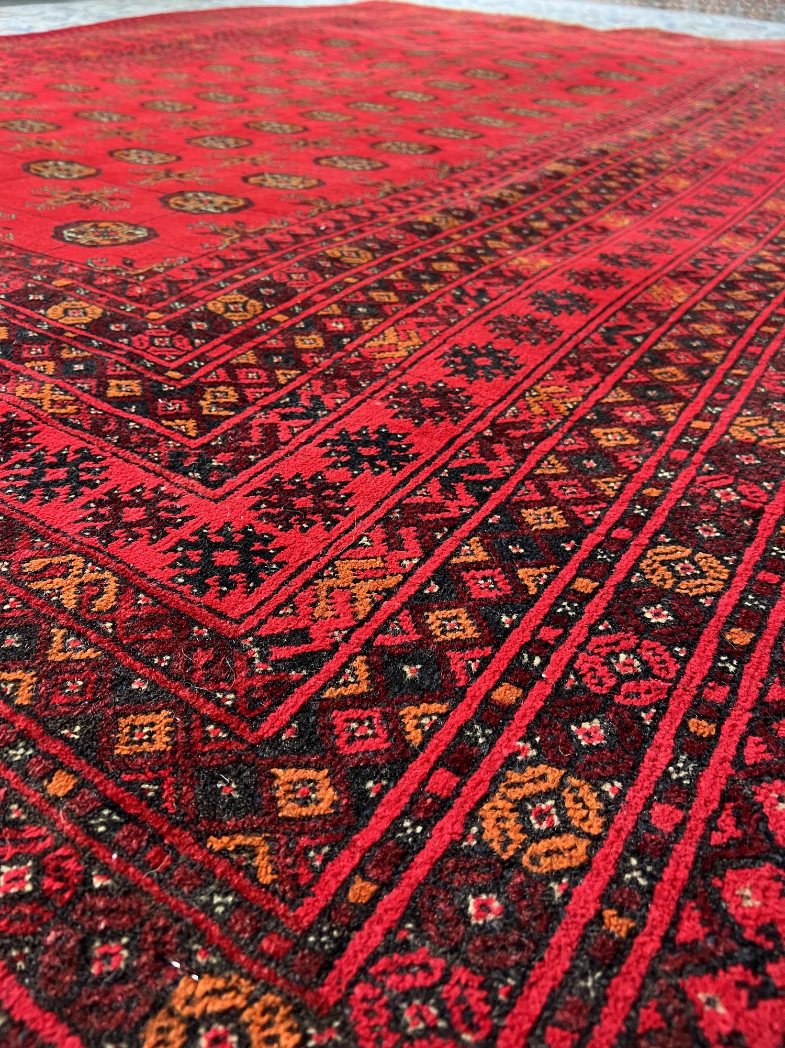

Select a Color and Pattern that Complements Your Decor.
When choosing an Australian rug for your home decor, it's important to select a color and pattern that complements the overall aesthetic of your space. Consider the existing color scheme and style of your room, and choose a rug that enhances and harmonizes with these elements. For example, if you have minimalist and modern decor, a rug with a simple and clean design in neutral tones may be the perfect choice. On the other hand, if you have a bohemian or eclectic style, you might opt for a rug with vibrant colors and intricate patterns. By selecting a color and pattern that complements your decor, you can create a cohesive and visually appealing space.

Determine the Rug's Purpose and Placement.
Before purchasing an Australian rug for your home decor, it's important to determine its purpose and where it will be placed. Consider the function of the rug - will it be used to add warmth and comfort to a living room or bedroom, or will it be placed in a high-traffic area like a hallway or entryway? This will help you choose the appropriate size and material for the rug. Additionally, consider the placement of the rug within the room. Will it be the focal point of the space or will it be used to define a specific area, such as under a dining table or in front of a fireplace? By determining the rug's purpose and placement, you can ensure that it not only enhances your home decor but also serves a practical function in your space.

Invest in Quality and Durability.
When choosing an Australian rug for your home decor, it's important to invest in quality and durability. A high-quality rug will not only look beautiful but will also stand the test of time. Look for rugs made from durable materials such as wool or synthetic fibers that are known for their longevity. Additionally, consider the construction of the rug. Hand-knotted rugs are typically more durable than machine-made rugs, as they are crafted with intricate detail and precision. While investing in a quality rug may require a higher upfront cost, it will ultimately save you money in the long run as you won't have to replace it as frequently. So, when shopping for Australian rugs, prioritize quality and durability to ensure that your investment lasts for years to come.
The Best Australian Rugs for Your Home Decor(Download PDF)

Links:
Wikipedia
Ikea

- Persian Rug The Art of Weaving: A Timeless Tradition
- Hallway Runners: Enhancing Your Space with Style and Practicality
- How to Hand Wash Your Persian Rug, Hall Runners
- How to Identify an Authentic Persian Rug: Tips and Tricks
- Why are Persian rugs so expensive?

