Persian Rug The Art of Weaving: A Timeless Tradition
chniques, and the reasons why acquiring a Persian rug from RugMaster can be the perfect addition to your Australian home. So, let's embark on a journey through the threads of time and unravel the beauty that is the Persian rug.

The Enchantment of Persian Rug
A Persian rug is not merely a floor covering; it's a piece of art that tells a story. For centuries, these rugs have graced the homes of royalty, dignitaries, and connoisseurs of beauty. The allure of Persian rugs lies in their intricate designs, vibrant colors, and skillful hands that bring them to life. At RugMaster, we understand the enchantment that Persian rugs bring to a space, and our collection is a testament to the time-honored tradition of Persian rug weaving.
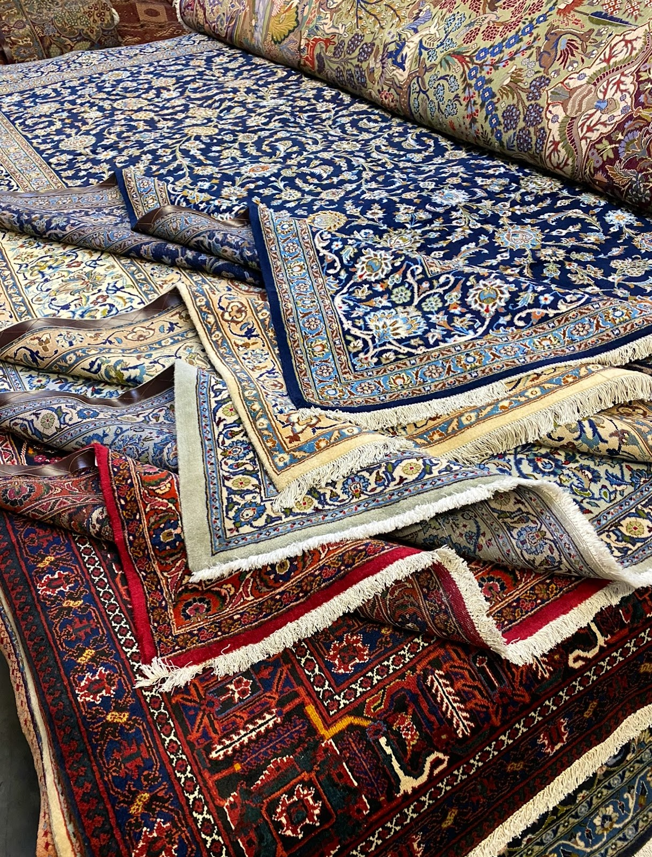

The Weaving Journey: From Tradition to Modernity
The art of Persian rug weaving dates back thousands of years, with each rug carrying a piece of the weaver's soul. The techniques used in creating these rugs have been passed down through generations, preserving the authenticity and uniqueness of each piece. At RugMaster, we take pride in offering a curated selection of Persian rugs that showcase both traditional motifs and modern interpretations. From the classic designs of Tabriz and Kashan to the intricate patterns of Isfahan and Nain, our collection reflects the evolution of Persian rug weaving while staying true to its roots.

A Symphony of Colors and Patterns
One of the most captivating aspects of Persian rugs is the harmonious blend of colors and patterns. Each rug tells a story through its motifs, symbols, and shades. Whether you prefer the bold and vibrant colors of tribal rugs or the subtle elegance of floral patterns, RugMaster's diverse range has something to suit every taste. Our rugs are meticulously handcrafted using premium materials, ensuring not only visual appeal but also durability that lasts for generations.
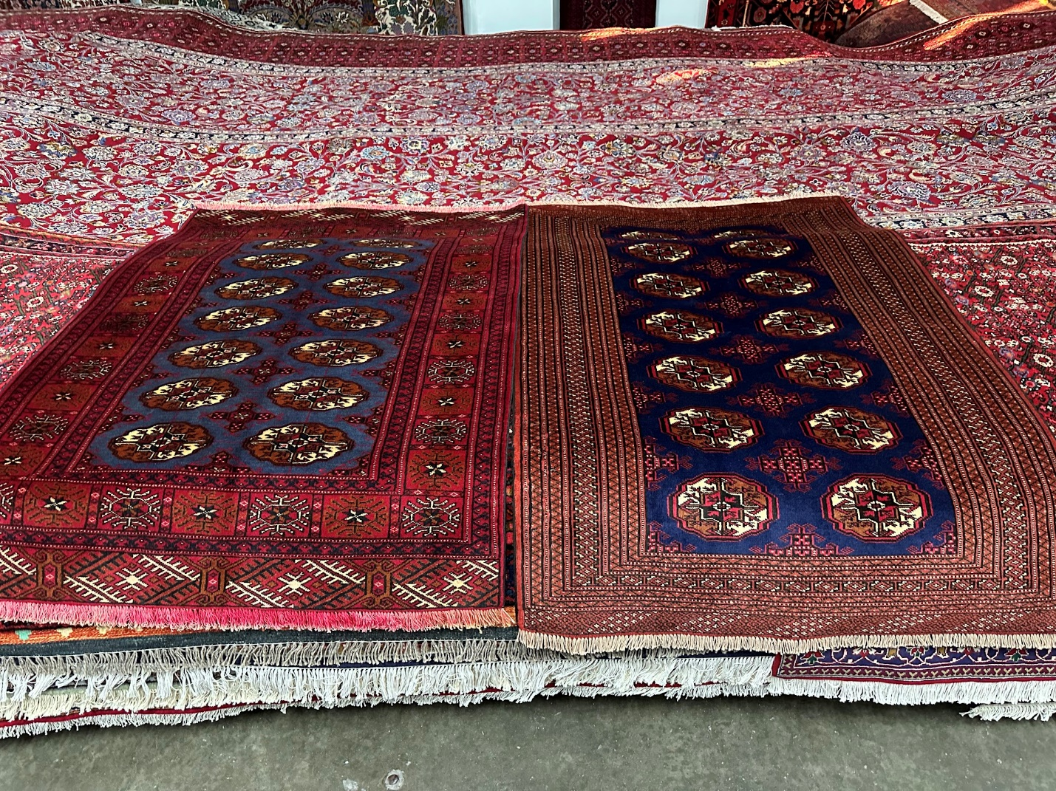

Craftsmanship Beyond Compare
At RugMaster, we understand the value of true craftsmanship. Each Persian rug in our collection is a testament to the skill and dedication of the artisans who create them. The weaving process involves intricate hand-knotting techniques that require precision and patience. As you run your fingers over the soft wool and silk threads, you can feel the passion and expertise that have gone into every knot. Our commitment to preserving this unparalleled craftsmanship is what sets RugMaster apart as a purveyor of genuine Persian rugs in Australia.

Unveiling History Through Threads
Owning a Persian rug is akin to owning a piece of history. These rugs have witnessed the rise and fall of empires, the passage of time, and the shifts in artistic expression. When you bring a Persian rug into your home, you're not just adding a decorative element; you're inviting centuries of culture and heritage. At RugMaster, we source rugs that carry stories of the past, allowing you to connect with the rich tapestry of Persian history.

RugMaster: Your Gateway to Timeless Beauty
As you embark on the journey to find the perfect Persian rug, RugMaster is your trusted companion. Our commitment to quality, authenticity, and customer satisfaction is unwavering. When you choose a Persian rug from RugMaster, you're not just making a purchase; you're making an investment in a piece of art that will enhance your living space and stand as a testament to the enduring beauty of Persian rug weaving.

Conclusion
The art of Persian rug weaving is a treasure trove of culture, history, and artistic brilliance. At RugMaster, we invite you to explore our exquisite collection of Persian rugs, each woven with care and infused with the spirit of tradition. As you adorn your Australian home with the beauty of a Persian rug, remember that you're not just buying a floor covering – you're embracing a timeless tradition that transcends generations. Experience the magic of Persian rug weaving with RugMaster, where every rug tells a story, and every thread is a brushstroke on the canvas of history.
Embrace the Legacy. Elevate Your Space. Choose RugMaster.

