Persian Rug: A Comprehensive Guide to Beauty and History
Persian rugs are some of the most sought-after and beautiful rugs in the world. With a rich history dating back thousands of years, Persian rugs have become a symbol of luxury, style, and sophistication. These rugs are known for their intricate designs, vibrant colors, and unparalleled quality. In this blog post, we'll delve into the world of Persian rugs and explore the reasons why they are so highly regarded by collectors, designers, and homeowners alike.
History of Persian Rugs
Persian rugs have a long and storied history, dating back to ancient times. The earliest known examples of Persian rugs were discovered in the Altai Mountains of Central Asia and date back to the 5th century BCE. These rugs were woven by nomadic tribes and were used primarily for warmth and insulation. Over time, Persian rug weaving became more sophisticated and evolved into an art form.
During the Safavid dynasty (1501-1722), Persian rug weaving reached its peak. The Safavid rulers encouraged the development of the arts, including rug weaving, and commissioned some of the most intricate and beautiful rugs ever created. These rugs were often commissioned by the royal court and were used to adorn palaces, mosques, and other important buildings.
In the 19th century, Persian rugs became increasingly popular in the West, and demand for these beautiful works of art grew exponentially. Today, Persian rugs are still highly sought after by collectors and homeowners worldwide.
Features of Persian Rugs
One of the most striking features of Persian rugs is their intricate designs. Persian rug designs are often inspired by nature and feature floral patterns, animals, and geometric shapes. These designs are usually created by hand, and each rug is unique.
Another important feature of Persian rugs is the quality of the materials used in their construction. Persian rugs are typically made from wool, silk, or a combination of the two. Wool is a durable and long-lasting material that is ideal for rug weaving. On the other hand, silk is a more luxurious material often used to create the intricate designs found in Persian rugs.
Persian rugs are also known for their vibrant colors. The dyes used in Persian rugs are often derived from natural sources, such as plants, flowers, and insects. This gives Persian rugs a rich and distinctive color palette unmatched by rugs from other parts of the world.
Finally, Persian rugs are renowned for their durability. Because they are made from high-quality materials and are often woven by hand, Persian rugs can last for generations with proper care and maintenance. This makes them a smart investment for anyone looking to add a touch of luxury and sophistication to their home.
Types of Persian Rugs
There are many different types of Persian rugs, each with its own unique style and characteristics. Here are a few of the most popular types of Persian rugs:
Tabriz Rugs: Tabriz rugs are known for their intricate designs and fine wool. They are often considered some of the most beautiful rugs in the world.
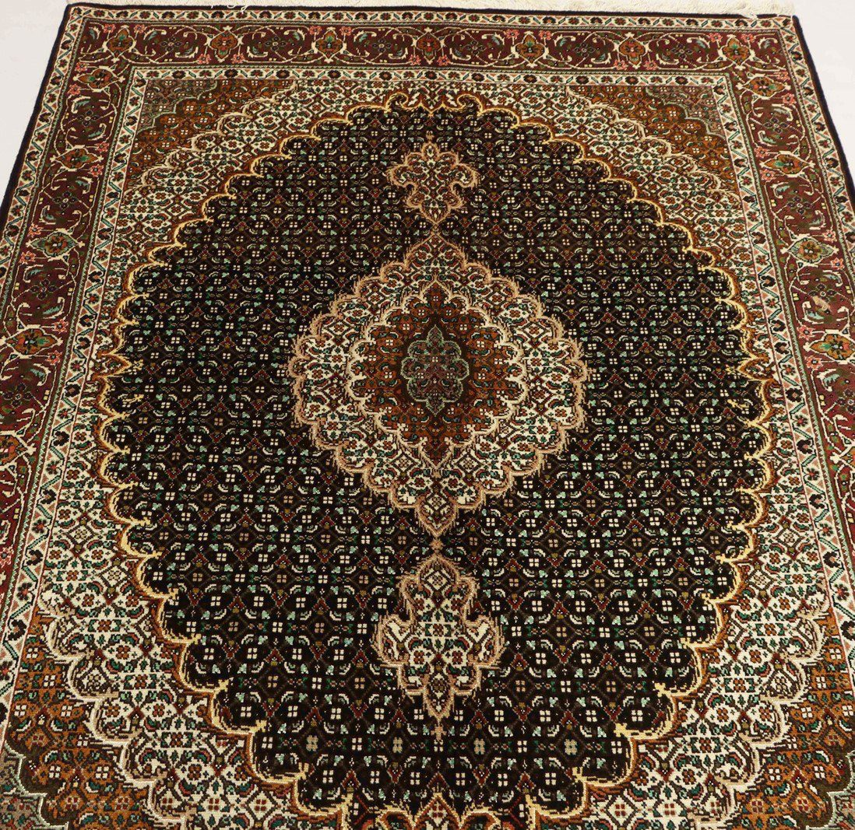
Kashan Rugs: Kashan rugs are known for their high-quality wool and intricate floral patterns. They are often considered some of the most luxurious rugs in the world.
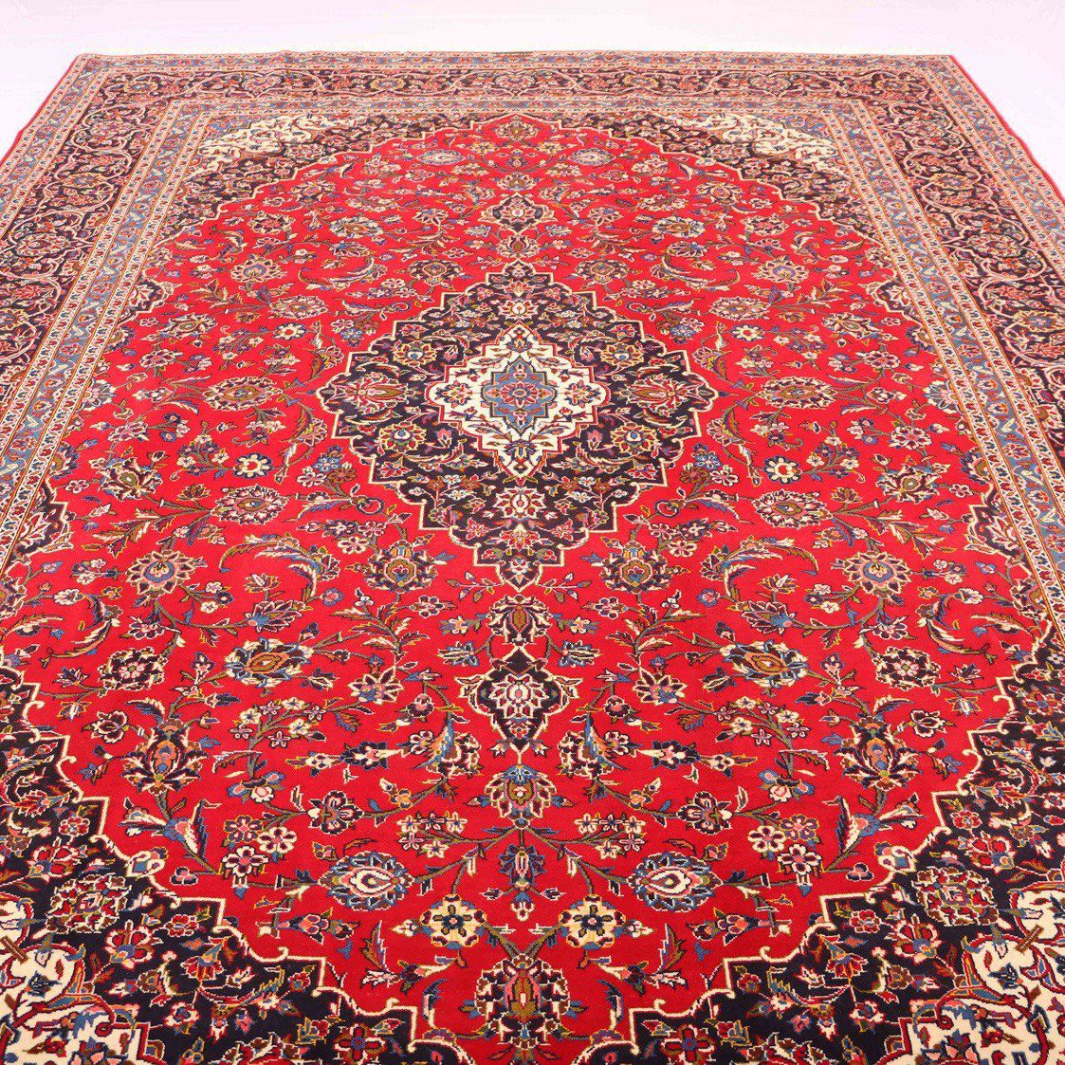
Isfahan Rugs: They are known for their fine silk and intricate medallion designs. They are often considered some of the most refined and elegant rugs in the world.
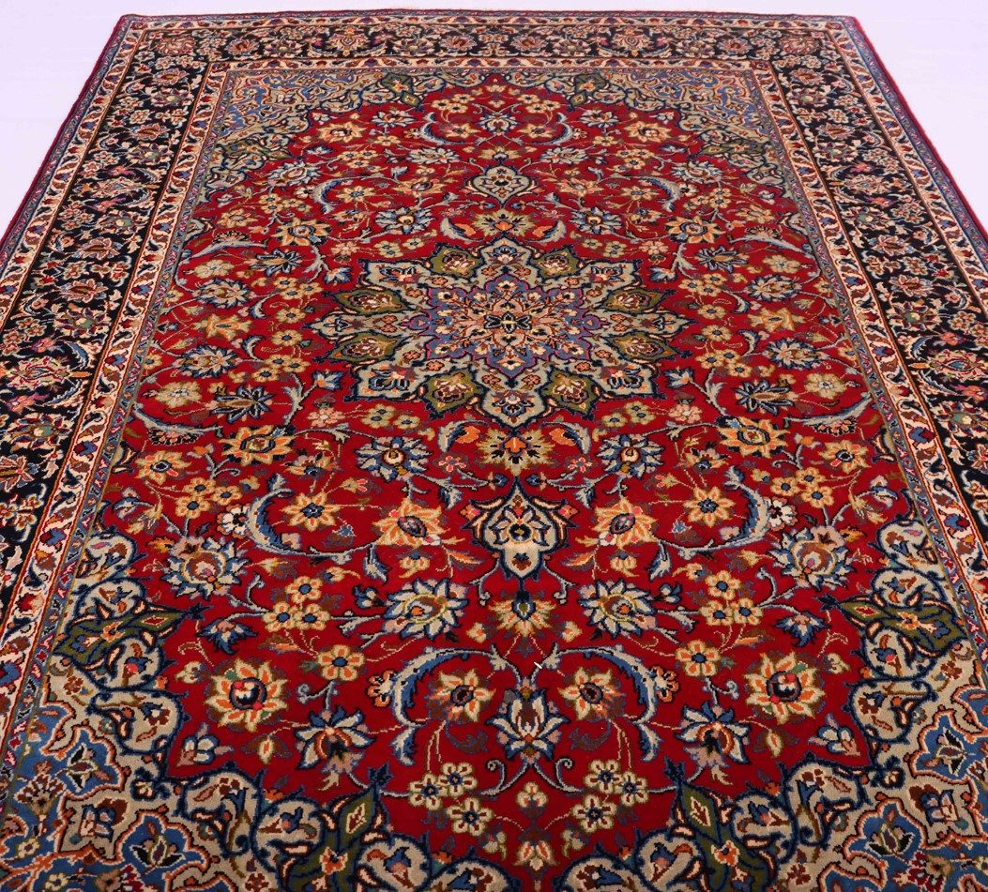
Nain Rugs: Nain rugs are known for their fine wool and intricate floral designs. They are often considered some of the world's most delicate and beautiful rugs.
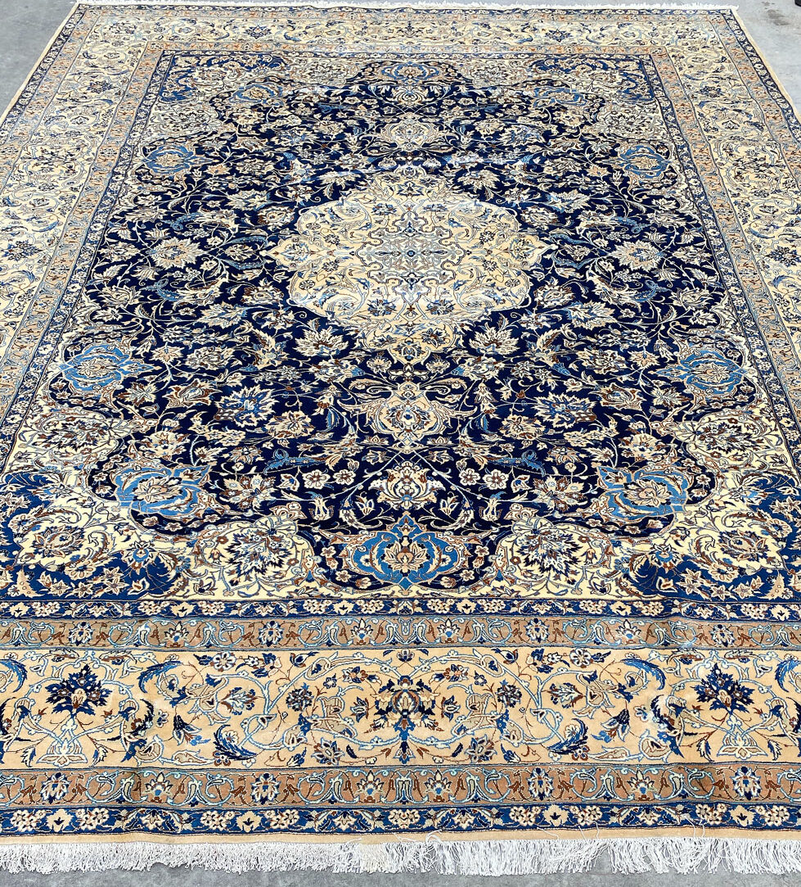
If you're considering buying a Persian rug, you should keep a few things in mind. First and foremost, y

