Interior Design with Oriental and Persian Rug Enhance Your Space
When transforming your living space, nothing quite captures the essence of luxury and comfort like the seamless integration of Oriental and Persian rugs. At RugMaster, we bring you an exclusive collection of these masterpieces, meticulously handwoven to perfection. In this comprehensive guide, we delve into the captivating world of interior design with these exquisite rugs, exploring how they can elevate your home decor, reflect your unique personality, and create a truly harmonious living environment.

The Artistry of Oriental and Persian Rugs
Oriental and Persian rugs are more than just floor coverings; they are works of art that tell stories of rich cultural heritage and timeless craftsmanship. Each rug is a testament to the artisan's dedication and skill, woven intricately with vibrant colors, intricate patterns, and symbolic motifs. As you embark on your interior design journey, consider these rugs as not just accessories but integral components that anchor and define your living spaces.
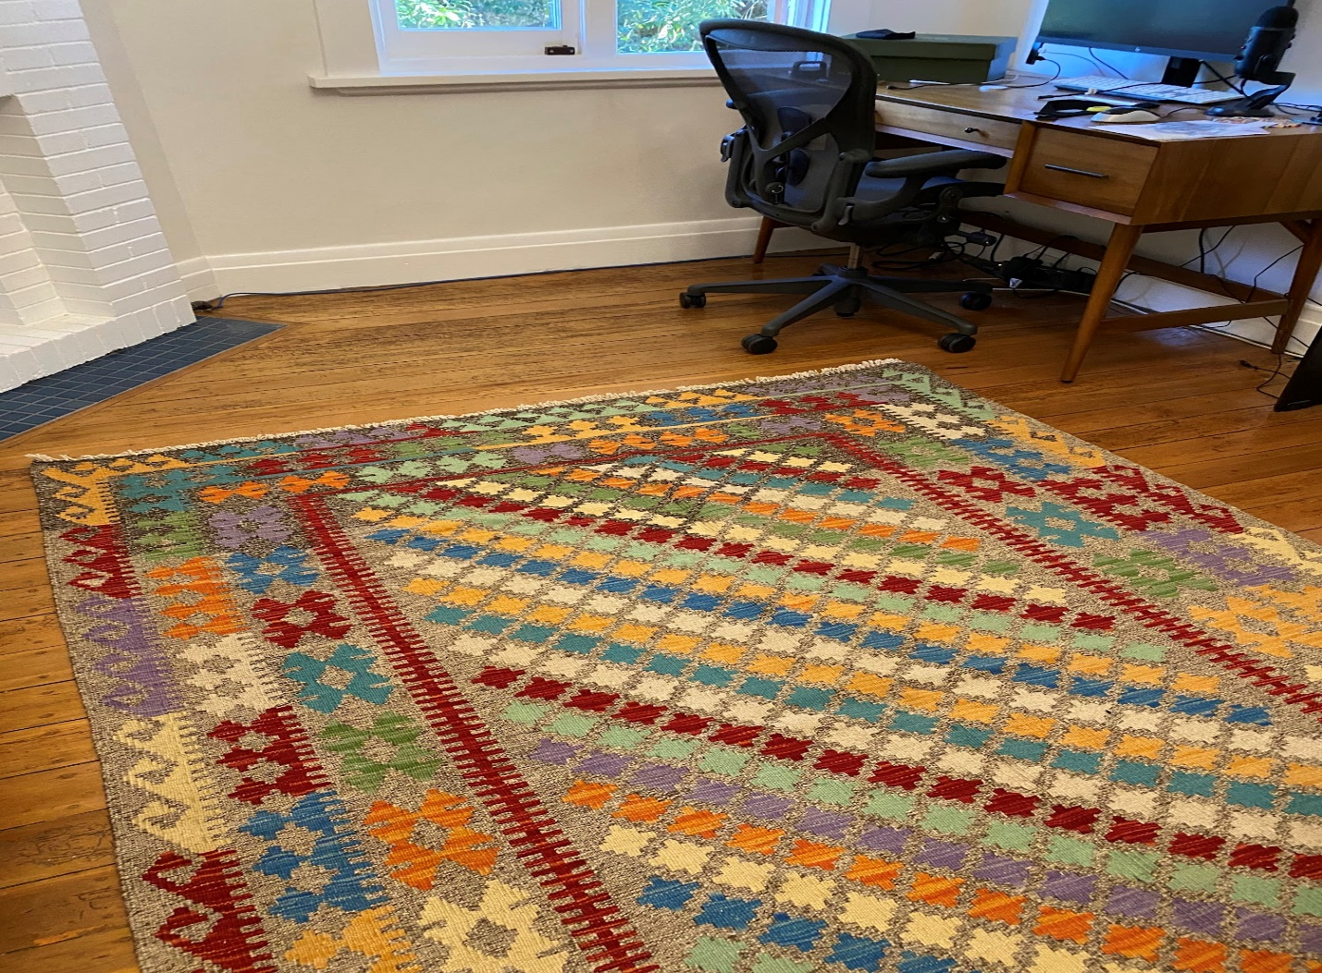

Harmonizing Tradition with Modernity
In the realm of interior design, the marriage of tradition and modernity is a delicate art. Oriental and Persian rugs effortlessly bridge this gap, offering a timeless allure that complements a wide range of design styles. Whether your home boasts a contemporary, minimalist aesthetic or embraces the opulence of classic decor, these rugs have the power to tie together disparate elements, creating a cohesive and visually pleasing atmosphere.
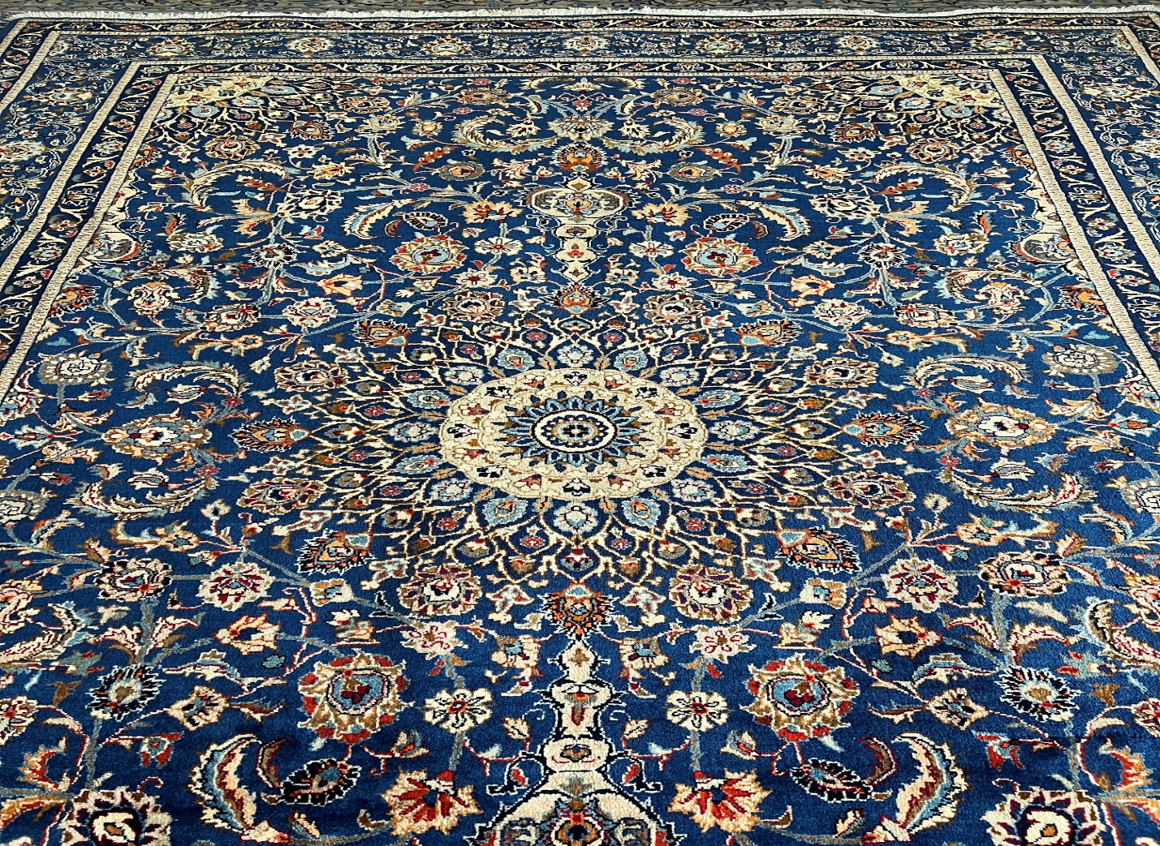

Elevating Your Aesthetic: RugMaster's Distinct Collection
At RugMaster, we take immense pride in curating a diverse range of Oriental and Persian rugs that cater to varied preferences. Our collection boasts an array of sizes, colors, and patterns, ensuring that you find the perfect rug to align with your interior design vision. Whether you're seeking a bold centerpiece for your living room or a subtle accent for your bedroom, RugMaster offers a tapestry of choices that enable you to express your individuality.

Creating a Focal Point
One of the cardinal principles of interior design is the creation of focal points within a room. An Oriental or Persian rug effortlessly assumes this role, drawing the eye and inviting intrigue. Imagine a luxurious handwoven rug, adorned with intricate designs, anchoring your dining area or gracing your entryway. Such a statement piece not only adds visual interest but also sets the tone for the entire space, igniting conversations and captivating guests from the moment they step inside.

Infusing Warmth and Comfort
Beyond their aesthetic appeal, Oriental and Persian rugs contribute to the tactile comfort of your home. The plush fibers underfoot provide a sense of warmth and coziness, making your living areas inviting retreats. As you recline on your sofa or gather with loved ones, the soft embrace of the rug's texture enhances the overall sensory experience, elevating moments of relaxation and togetherness.
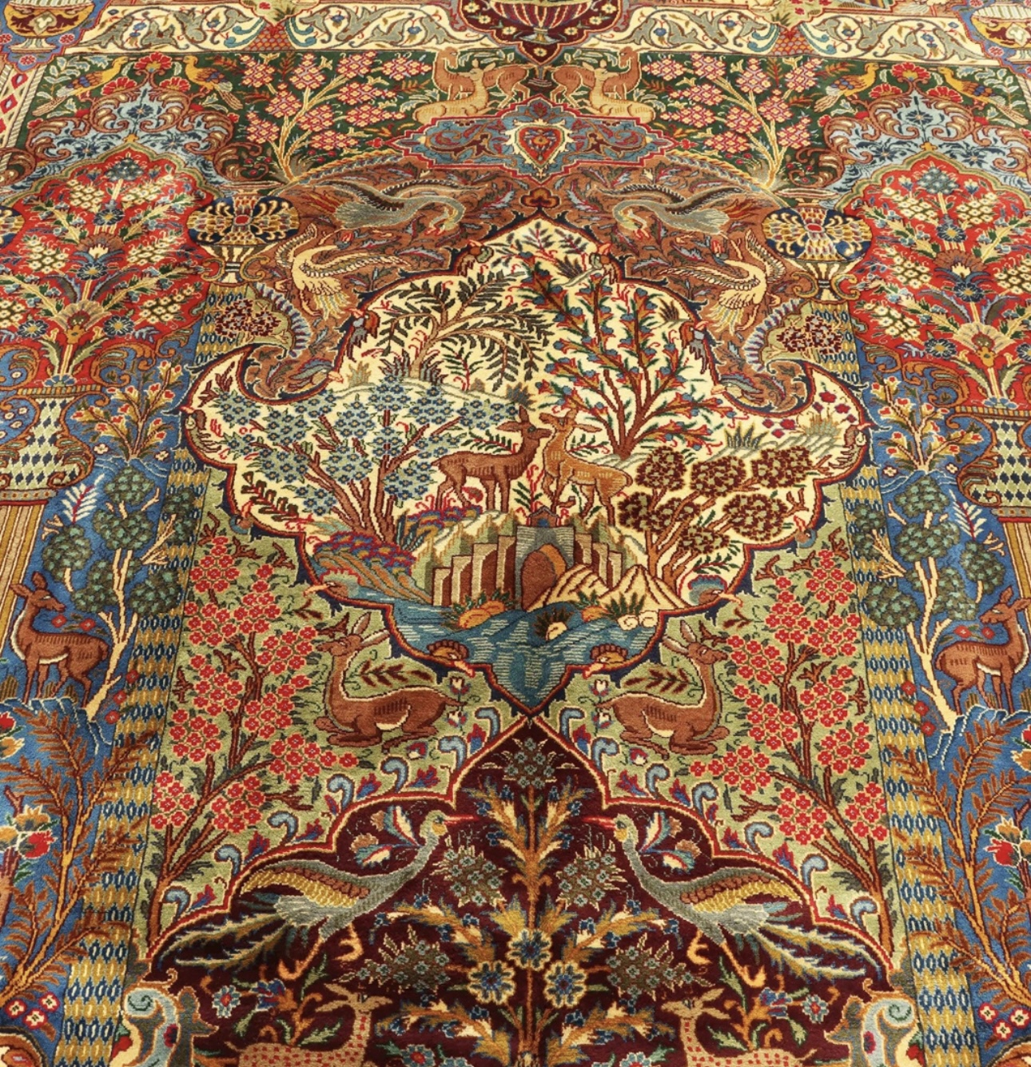

The Versatility of Design
With an Oriental or Persian rug as your design anchor, the possibilities are virtually limitless. These rugs complement an array of interior design styles, from bohemian and eclectic to traditional and transitional. Layered over hardwood floors or juxtaposed against contemporary tiles, their versatility is unmatched. Moreover, as you evolve your interior decor over time, these rugs adapt seamlessly, promising lasting beauty and relevance.

Unveiling a World of Possibilities: Free Shipping Across Australia
RugMaster not only takes pride in offering an exquisite collection of Oriental and Persian rugs but also extends unparalleled convenience through our Australia-wide free shipping. Regardless of your location, you can now embrace the allure of these rugs without the concern of added costs. Our commitment to delivering quality and elegance to your doorstep underscores our dedication to enhancing your interior design journey.

Conclusion: Weaving Dreams into Reality
In the realm of interior design, every element contributes to the tapestry of your home's narrative. Oriental and Persian rugs from RugMaster weave dreams into reality, infusing your space with culture, elegance, and comfort. As you embark on your quest to enhance your living spaces, let the artistry of these rugs guide you and experience the transformation that comes with embracing the timeless charm of Oriental and Persian design. Your home is a canvas; let RugMaster help you paint an exquisite masterpiece.
Discover RugMaster's captivating collection today and take the first step toward elevating your interior design journey.

