How to Identify an Authentic Persian Rug: Tips and Tricks
persian rugs are known for their intricate designs, beautiful colors, and fine craftsmanship. However, with the rise of machine-made rugs and counterfeit products, it can be challenging to identify an authentic Persian rug. In this article, we will provide some tips and tricks to help you determine whether your Persian rug is genuine.
Look at the Knots:
The knots on a Persian rug are a good indication of its authenticity. Handmade Persian rugs have asymmetrical knots, which means that the knots are not uniform in size and shape. On the other hand, machine-made rugs have symmetrical knots, which are uniform in size and shape. You can easily identify the type of knot by flipping the rug over and looking at the back. If the knots are asymmetrical, the rug is likely handmade.
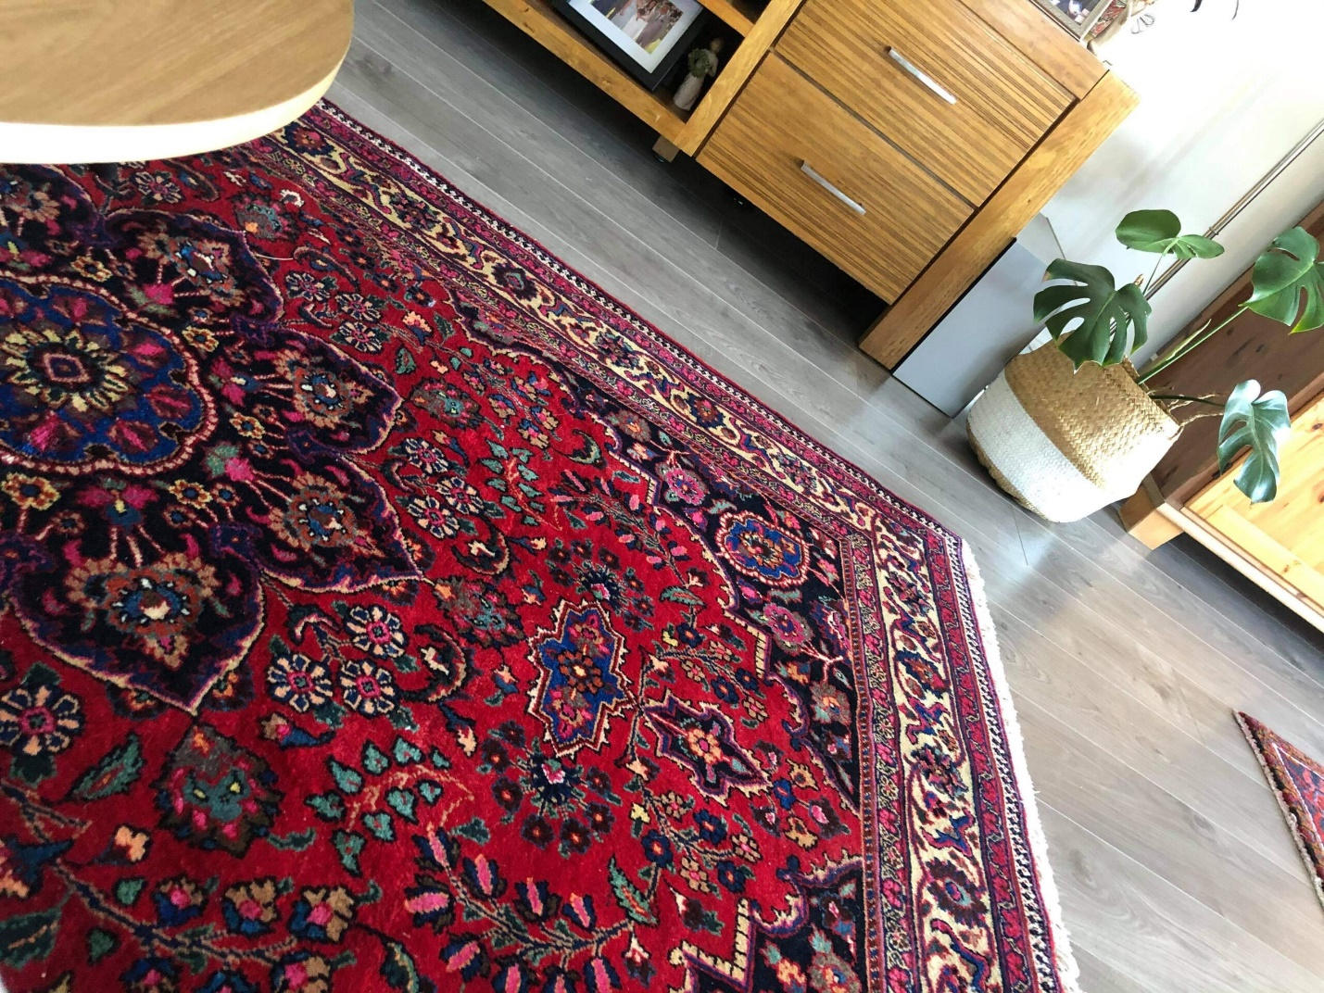
Check the Material:
Persian rugs are made of natural wool, silk, and cotton fibers. If your rug is made of synthetic materials such as nylon or polyester, it is unlikely to be an authentic Persian rug. Check the label on the rug or consult a professional if you are unsure about the materials used.
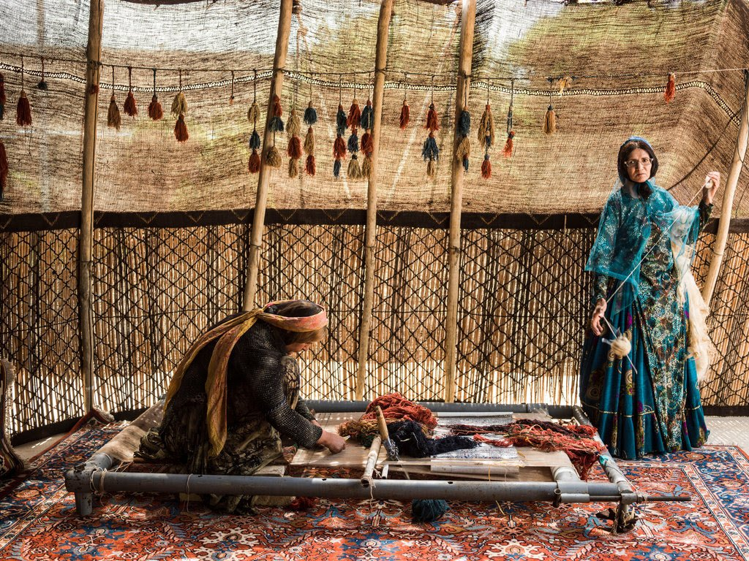
Examine the Design:
Persian rugs are known for their intricate designs, which are usually symmetrical and highly detailed. If the design on your rug is too perfect or appears to be computer-generated, it may be a machine-made rug. Authentic Persian rugs often have slight imperfections or variations in the design resulting from being handmade.
Look for Age and Wear:
Vintage and antique Persian rugs are highly sought after and often more valuable than newer rugs. If your rug is a vintage or antique piece, it
Seek Professional Help:
If you are still unsure about your Persian rug's authenticity, seek a professional's help. A rug expert or appraiser can examine the rug and provide you with a detailed assessment of its authenticity, age, and value.
Conclusion:
A Persian rug is a beautiful addition to any home, but it's important to ensure that you are purchasing an authentic piece. By examining the knots, material, design, age, and wear, you can identify whether your rug is handmade or machine-made. Remember, if you are still unsure, seek the help of a professional to ensure that you are investing in a genuine Persian rug. Shop for the best quality handwoven Persian rugs, traditional rugs, vintage rugs, tribal rugs, Tabriz rugs, hall runners, and more at our online Persian rug store in Australia.

