How to Hand Wash Your Persian Rug, Hall Runners
are a beautiful addition to any home, adding warmth and texture to a room. Handmade rugs, in particular, are prized for their quality and unique designs. However, rugs can become dirty and stained over time and may require a thorough cleaning to restore their beauty. While machine washing may seem like a convenient option, it can damage delicate fibers and cause colors to fade. A better option is to hand wash your rug, which allows you to carefully control the cleaning process and ensure that your rug stays in top condition.
If you're looking to hand wash your rug, here are some tips to help you get started:
- Choose the Right Location
Before you begin, choose a well-ventilated rug hand wash location with enough space to spread out your rug. Ideally, you should choose an outdoor location like a patio or driveway. If you don't have an outdoor space, choose a room with a tiled or concrete floor that can be easily cleaned.
- Vacuum the Rug
Before washing your rug, vacuum it thoroughly to remove any loose dirt and debris. This will make cleaning more effective and prevent dirt from getting trapped in the fibers.
- Mix the Cleaning Solution
Next, mix a cleaning solution that is appropriate for your rug's material. For wool rugs, a gentle detergent or wool wash is recommended. For silk rugs, mild soap or shampoo can be used. Mix the cleaning solution with warm water in a large bucket or basin.
- Test the Cleaning Solution
Before you start washing your rug, it's a good idea to test the cleaning solution on a small, inconspicuous area of the rug to make sure it doesn't cause any damage or discoloration. Wait a few minutes to see if any adverse reactions occur before proceeding with the full cleaning process.
- Wash the Rug
You can begin washing your rug once you've tested the cleaning solution. Use a soft-bristled brush or sponge to gently scrub the rug in a circular motion, working from the center outwards. Be careful not to scrub too hard, which can damage the fibers. Rinse the rug thoroughly with clean water to remove any soap residue.
- Dry the Rug
After washing, it's important to dry your rug properly to prevent mold and mildew from forming. Hang the rug over a clothesline or railing in a well-ventilated area, or lay it flat on a clean, dry surface. Avoid exposing the rug to direct sunlight, which can cause colors to fade. Allow the rug to dry completely before using it again.
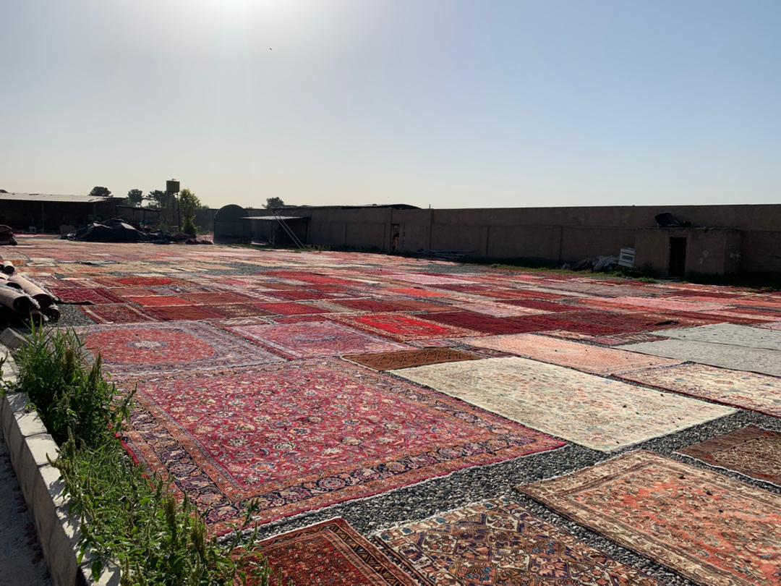
Regular cleaning is essential when it comes to maintaining your rug's beauty and quality. By hand washing your rug, you can ensure it stays in top condition for years.
RugMaster offers a wide selection of handmade rugs to suit any style and budget. Our Persian rugs, hall runners, and wool rugs are all made with the highest quality materials and craftsmanship and are available at competitive prices. Plus, with free shipping Australia-wide, finding the perfect rug for your home is easy. Thank you for choosing RugMaster for your rug shopping needs - contact us today for more information about our quality rugs with complimentary nationwide delivery.

