Hallway Runners: Enhancing Your Space with Style and Practicality
Looking to elevate the style and functionality of your hallway? Look no further than hallway runners. These versatile floor coverings are not only a practical solution for high-traffic areas but also a stunning design element that can transform your space. Whether you have a narrow corridor or a grand entrance, hallway runners are the perfect way to add warmth, texture, and personality to any hallway. From intricate patterns to solid colors, there is a wide range of options available to suit every taste and interior design theme. But it's not just about aesthetics – hallway runners also serve a practical purpose by protecting your floors from scratches, reducing noise, and providing a comfortable walking surface. In this article, we'll explore the many benefits of hallway runners and share some tips on how to choose the perfect one for your home. Get ready to enhance your space with style and practicality!

Benefits of using hallway runners
Hallway runners offer a multitude of benefits that make them an essential addition to any home. Firstly, they protect your floors from scratches and damage caused by heavy foot traffic. Hallways are often the busiest areas of a home, with people constantly coming and going. Without proper floor covering, the constant friction can wear down the flooring material over time. Hallway runners act as a protective barrier, preserving the beauty and longevity of your floors.
Another advantage of hallway runners is their ability to reduce noise. Hardwood or tile floors can be quite noisy, especially when shoes or heels make direct contact. The sound can echo throughout the house, disrupting the peace and quiet. By placing a hallway runner, you create a sound-absorbing layer that dampens the noise, making your home a more peaceful environment.
In addition to practical benefits, hallway runners also add a touch of warmth and comfort to your space. The soft texture of the runner creates a cozy atmosphere, making your hallway more inviting. It provides a comfortable walking surface, reducing the strain on your feet and joints. Whether you're barefoot or wearing slippers, the plush feel of a hallway runner makes each step a pleasant experience.
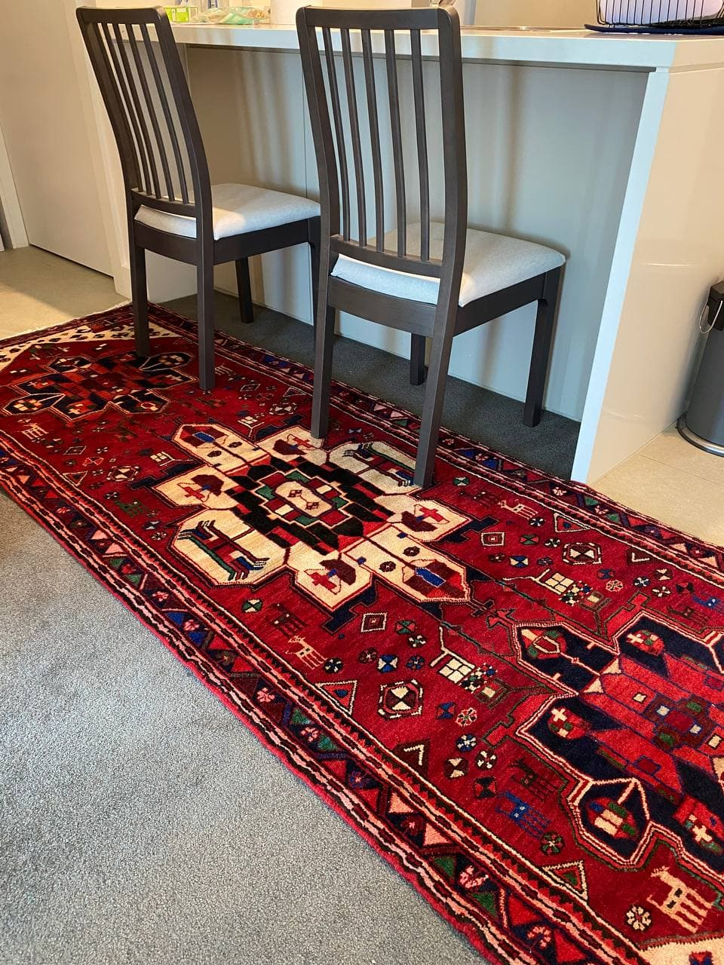

Types of hallway runners
When it comes to hallway runners, there is a wide variety of options to choose from. The type of runner you select will depend on your personal style, the size of your hallway, and the overall aesthetic of your home. Let's explore some popular types of hallway runners:
1. **Traditional Runners**: Traditional runners are characterized by intricate patterns and rich colors. They often feature motifs such as florals, medallions, or oriental designs, adding an elegant and timeless touch to your hallway. These runners are perfect for classic or vintage-inspired interiors.
2. **Modern Runners**: If you prefer a more contemporary look, modern runners are a great choice. They typically feature bold geometric patterns, abstract designs, or minimalistic motifs. These runners add a fresh and stylish vibe to any hallway, complementing modern or Scandinavian interior styles.
3. **Natural Fiber Runners**: Made from materials such as jute, sisal, or seagrass, natural fiber runners are an excellent option for those seeking a rustic or bohemian aesthetic. These runners bring a touch of nature indoors, creating a warm and organic feel. They are also durable and sustainable, making them an eco-friendly choice.
4. **Solid Color Runners**: For a more understated and versatile look, consider a solid color runner. Available in a wide range of hues, from neutrals to vibrant shades, these runners can easily adapt to any interior style. They provide a clean and minimalistic base, allowing other elements in your hallway to take center stage.
When choosing a hallway runner, consider the overall color scheme and design of your hallway. Determine whether you want the runner to be the focal point or a complementary element. Additionally, consider the size of your hallway and select a runner that fits the space proportionately.

Choosing the right size and style
Choosing the right size and style of a hallway runner is crucial to achieving the desired aesthetic and functionality. Here are some tips to help you make the right choice:
1. **Measure your hallway**: Before purchasing a runner, measure the length and width of your hallway. Take note of any obstacles, such as doors or furniture that may impact the placement of the runner. This will help you determine the appropriate size for your runner and ensure a perfect fit.
2. **Consider the scale**: The scale of the runner should be proportional to the size of your hallway. In a narrow hallway, a wide runner may overwhelm the space, while a narrow runner may get lost in a large hallway. Aim for a balance that complements the dimensions of your hallway.
3. **Coordinate with existing decor**: Take into account the existing design elements in your hallway, such as wall colors, lighting fixtures, and artwork. Choose a runner that complements the overall aesthetic of your space. If you have bold or busy wallpaper, opt for a simpler runner that won't clash with the pattern.
4. **Test different styles**: If you're unsure about the style of runner that would work best, consider testing out different options. Purchase a few runners in varying patterns and colors, and place them in your hallway to see how they look. This will give you a better idea of what works and what doesn't before making a final decision.
Remember, the goal is to select a runner that enhances the visual appeal of your hallway while serving its practical purpose.

Hallway runner materials and durability
Hallway runners come in a variety of materials, each with its own unique characteristics and level of durability. Here are some common materials used in hallway runners:
1. **Wool**: Wool runners are popular due to their natural beauty and durability. Wool is a soft and luxurious material that adds warmth and comfort to your space. It is also naturally stain-resistant and flame-retardant, making it a practical option for high-traffic areas.
2. **Synthetic fibers**: Runners made from synthetic fibers such as nylon, polyester, or polypropylene are known for their durability and affordability. These materials are resistant to stains, fading, and wear, making them ideal for hallways with heavy foot traffic or households with pets and children.
3. **Natural fibers**: Natural fiber runners, such as jute, sisal, or seagrass, bring a touch of organic beauty to your hallway. These materials are environmentally friendly and biodegradable. However, they are less resistant to stains and moisture, so they may require more care and maintenance.
When choosing a material, consider the level of foot traffic in your hallway, the presence of pets or children, and your personal preferences for texture and comfort.
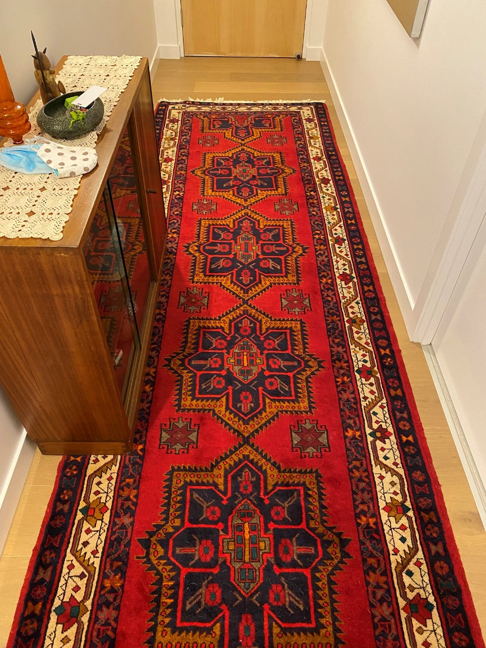

Hallway runner placement and installation tips
Proper placement and installation of a hallway runner can make all the difference in enhancing your space. Here are some tips to help you achieve the best results:
1. **Centered placement**: In most cases, it's aesthetically pleasing to center the hallway runner between the walls. This creates a balanced and symmetrical look. However, if you have an irregularly shaped hallway, you may need to adjust the placement to accommodate the space.
2. **Consider the length**: Ideally, the runner should cover a significant portion of the hallway, extending beyond the entrance and exit points. This ensures that the runner serves its practical purpose by protecting the entire length of the floor.
3. **Secure the runner**: To prevent slipping and tripping hazards, it's important to secure the runner in place. You can use rug grippers, double-sided tape, or a non-slip rug pad to keep the runner in position. These accessories also help protect your floors from damage caused by friction.
4. **Maintain proper spacing**: Leave a small gap between the runner and the walls to create a border. This prevents the runner from looking cramped and allows the flooring underneath to breathe.
Remember, the placement and installation of a hallway runner should be tailored to your specific space and needs. Don't be afraid to experiment and make adjustments until you achieve the desired look and functionality.

Hallway runner maintenance and cleaning
To keep your hallway runner looking its best and prolong its lifespan, regular maintenance and cleaning are essential. Here are some tips to help you maintain your runner:
1. **Vacuum regularly**: Vacuuming your hallway runner on a weekly basis helps remove dirt, dust, and debris that can accumulate over time. Use a vacuum cleaner with a brush attachment to gently clean the surface of the runner.
2. **Spot clean spills immediately**: In the event of a spill or stain, address it promptly to prevent permanent damage. Blot the affected area with a clean cloth or paper towel, and avoid rubbing, as it can spread the stain. Use a mild detergent or carpet cleaner specifically designed for the runner's material, and follow the manufacturer's instructions.
3. **Rotate the runner**: To prevent uneven wear and tear, rotate the runner periodically. This ensures that the foot traffic is distributed evenly across the runner, extending its lifespan.
4. **Professional cleaning**: Consider getting your hallway runner professionally cleaned every 12 to 18 months, depending on the level of foot traffic. Professional cleaning helps remove deep-seated dirt and allergens, revitalizing the appearance of your runner.
By following these maintenance and cleaning tips, you can enjoy a clean and fresh-looking hallway runner for years to come.

Hallway runner design ideas and inspiration
Now that you have a better understanding of the benefits, types, and maintenance of hallway runners, let's explore some design ideas and inspiration to spark your creativity:
1. **Monochromatic elegance**: Create a sophisticated and timeless look by choosing a hallway runner in a neutral color such as gray, beige, or cream. Pair it with matching wall paint and add a few statement pieces like a mirror or artwork to complete the elegant aesthetic.
2. **Bold patterns and colors**: Make a statement with a hallway runner featuring bold patterns or vibrant colors. This adds a pop of personality to your space and can be particularly effective in hallways with minimalistic or monochromatic interiors.
3. **Texture and layers**: Experiment with texture by layering different rugs or runners in your hallway. Mix and match materials such as wool, jute, or sisal to create a visually interesting and cozy atmosphere.
4. **Eclectic charm**: Embrace an eclectic style by combining different patterns and textures in your hallway. Play with mismatched runners, vintage rugs, and unique accessories to create a dynamic and eclectic space.
Remember, the design possibilities are endless, and the key is to choose a hallway runner that reflects your personal style and complements the overall aesthetic of your home.
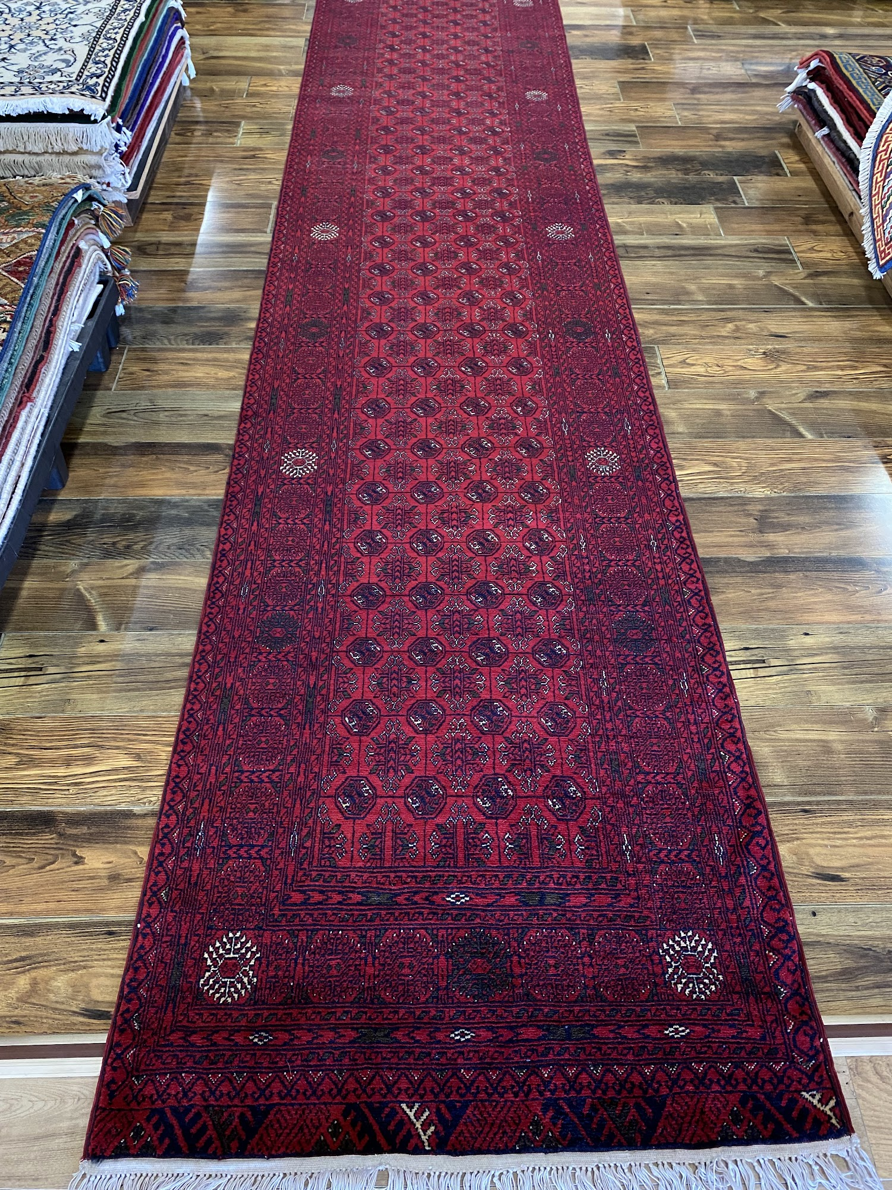

Where to buy hallway runners
Now that you're ready to enhance your space with a hallway runner, you may be wondering where to find the perfect one.
RagMaster, with many years of experience in importing quality rugs and runners to Australia, is your only option for quality shopping in Australia.
The reason for its popularity is the incredible prices compared to competitors, shipping services, professional advice, and thousands of other services.
No matter where you choose to buy your hallway runner, be sure to read customer reviews, check the return policy, and consider the reputation of the seller.

Conclusion: Elevating your space with hallway runners
Hallway runners are more than just floor coverings – they are a versatile design element that can transform your space. From adding warmth and texture to protecting your floors and reducing noise, hallway runners offer numerous benefits. By choosing the right size, style, and material, you can enhance the aesthetic appeal and functionality of your hallway. Proper placement, installation, and maintenance ensure that your runner remains in top condition for years to come. So, whether you're looking for a traditional pattern, a modern design, or a natural fiber runner, there is a perfect hallway runner out there for you. Start exploring your options and elevate your space with style and practicality today!

